**Seismic Performance of Finite Slopes Stabilized with Nano-Silica: A Pseudo-static Approach for Earthquake Resilience**

**Ishwor Thapa and Sufyan Ghani****\***

*1Department of Civil Engineering, Sharda University, Greater Noida, India*

**\* Corresponding Author:** [*sufyan.ghani@sharda.ac.in*](mailto:sufyan.ghani@sharda.ac.in)

**Abstract**

This study investigates the seismic performance of finite slopes stabilized with Nano-silica (NS) under earthquake forces using a pseudo-static approach. Numerical simulations were conducted using finite element modeling to assess the stability of slopes with varying NS dosages, slope angles, and stability ratios. The safety factor and horizontal displacement (*H*d) were determined under seismic loading, and a comparative analysis between NS-stabilized and non-stabilized slopes was performed. Results revealed that NS-stabilized slopes exhibited a safety factor improvement of up to 6.7 times compared to non-stabilized slopes under earthquake forces, with corresponding reductions in horizontal displacement. Reliability analysis further indicated that the probability of failure for NS-stabilized slopes was reduced to 12.97%. These findings underscore the potential of NS as an effective stabilizer in enhancing seismic resilience of slopes in earthquake-prone regions.

**Keywords:**  *Seismic slope stability, Nano-silica, Pseudo-static analysis, Seismic resilience, Finite element modeling, Earthquake forces, Reliability analysis.*

**1 Introduction**

A crucial component of geotechnical engineering is slope stability, particularly in areas where seismic activity is common. It is crucial to maintain slope stability during earthquakes to avoid catastrophic failures that could cause large financial losses, environmental harm, and fatalities(Kumari et al., 2024; Ghani, Sapkota, et al., 2024; Ghani and Kumari, 2024). Retaining structures, drainage management, and mechanical reinforcement are examples of conventional techniques for improving slope stability. However, these techniques are expensive and sometimes impractical. Innovative materials, such as Nano-silica (NS), which have shown promise in enhancing soil stability and characteristics, have been made possible by the development of nanotechnology. The dynamic loads imposed by seismic forces on slopes can drastically diminish their stability. The inertial forces produced by an earthquake may cause the slope material to experience additional stresses, which could eventually cause failure. One approach that is frequently used to assess a slope's stability during seismic activity is pseudo-static analysis. By substituting an equivalent static problem for the dynamic problem, this approach makes computation and evaluation simpler.

Conventional slope stability assessments struggle to consider different loading situations and geometries because of the simplified stress analysis in the soil mass. For this reason, slope stability analyses have been using finite element programs (PLAXIS 2D, etc.) increasingly recently (Sumit Kumar et al., 2023a). Additionally, the finite elements method can be utilized with ease to evaluate a slope's stability over the short or long term, ascertain the levels of subterranean water, and enhance slopes using a variety of techniques (such as stone columns, stakes, rock bolts, and geosynthetics) (Zhou et al., 2020).

The analysis of slope stability also focuses on how the slope, a geometric mass of soil, behaves under seismic forces. The two main types of analyses for the seismic evaluation of slope stability are weakening slope stability analysis and inertia slope stability analysis. Two popular techniques for inertia slope stability analysis are the pseudo-static and Newmark approaches (Mircevska et al., 2022). These techniques rank among the most widely used techniques for assessing a slope's seismic resilience. Pseudo-static slope analysis has been the subject of numerous investigations (Patra et al., 2020; Ye et al., 2023; Sharma et al., 2023; Hazari et al., 2022; Beygi et al., 2022; Long Wang et al., 2024; Khorsandiardebili et al., 2022). The primary focus of these studies is selecting the coefficient in the pseudo-static method, overall procedures, and the advancement of the method. Previous studies did not explore the impact of earthquake force (pseudo-static) on the behaviour of an enhanced slope. It is believed that this circumstance creates a gap in the literature.

A slope must be able to withstand both stationary and earthquake-induced forces. If not, alternate methods of enhancing should be used to reach slope stabilization. Various methods outlined in the literature, such as surface drainage, relieving, waste additives, stability with the wall, outfitting the slope, excavation, underpinning, compaction of the soil, stone columns, and planting, are used for slope stabilization. (Nitish Kumar et al., 2024; Banne et al., 2024; Spiekermann et al., 2021; Sumalatha, 2022; Ijaz et al., 2022; Rehman et al., 2023; Farooq et al., 2020) are just a few of the numerous studies that have been conducted on the stability of embankments and splitting slopes when trying to improve them with the help of additives. According to these investigations, using various soil stabilizers slope stability can be done successfully.

**Table 1** Relevant Literature related to the current study

|  |  |  |  |  |
| --- | --- | --- | --- | --- |
| **Reference** | **Slope Type** | **Stabilization Method** | **Forces considered** | **FOS** |
| (Çadır et al., 2021a) | Finite | Stone Column | Earthquake | 1.795 |
| (NG et al., 2022) | Finite | soil–plant-biochar interaction | Gravity | 1.45 |
| (Dar et al., 2021) | Finite | Stone Column | Earthquake | 1.9 |
| (Jaiswal et al., 2022) | Finite | geogrid | Earthquake | 1.39 |
| (Singh et al., 2021) | Finite | Soil nailing | Static | 1.77 |
| (Singh et al., 2021) | Finite | Soil nailing | Earthquake | 1.34 |
| (Li et al., 2022) | Infinite | - | Gravity | 1.7 |
| (Chen et al., 2024) | Infinite | - | Gravity | 1.55 |

As shown in Table 1, many researchers have employed both computational and empirical approaches to examine the stability of slopes with additives under various conditions, including static, gravitational, and seismic loads. However, studies exploring the stability of slopes incorporating NS when subjected to earthquake forces appears missing. The primary objective of this study is to assess the seismic performance of finite slopes stabilized with varying dosages of Nano-silica under pseudo-static earthquake forces. The study aims to quantify the improvement in safety factors and reduction in horizontal displacement due to NS stabilization, providing a reliable approach to enhancing the seismic resilience of slopes. Additionally, the study seeks to validate the reliability of this stabilization method through probabilistic analysis, contributing to the development of best practices for slope stabilization in earthquake-prone regions.

The research introduces the innovative use of NS for stabilizing finite slopes subjected to seismic forces, offering a first of its kind approach for enhancing slope stability in earthquake-prone regions. Unlike traditional slope stabilization methods, the use of NS provides a cost-effective and high-performance alternative with a significant reduction in failure probability under seismic conditions. The study’s use of pseudo-static analysis in combination with finite element modeling contributes to the growing body of knowledge on advanced materials and methods for seismic slope stabilization.

The safety factor for the study was determined by analyzing the angle of slope (β: 30°, 45°) and unstabilized slope with different c/(γ.H) ratios using the PLAXIS 2D finite element program. Next, under the influence of pseudo-static seismic force, the safety factor was calculated using the same c/(γ.H) ratio and slope angle. Following this, the slopes stabilized with various dosages of NS and various internal friction angles and cohesion are examined, and the values for the safety factor and Hd are discovered. Finally, the safety factor of slopes stabilized with NS with similar characteristics was calculated under the influence of pseudo-static earthquake force, using the same slope angle and c/(γ.H) ratio. In the final section, the safety improvement factor (SIF) for slopes subjected to pseudo-static earthquake forces was calculated and all research results were analyzed side by side.

* 1. **Research Significance**

This research explores a crucial topic in geotechnical engineering, particularly relevant to areas that are vulnerable to earthquakes. The research introduces an innovative material that exhibits a large surface area, demonstrates pozzolanic reactivity, and possesses the ability to enhance soil mechanical characteristics when used as a stabilizer. Slopes' strength and durability could be greatly increased by using this approach. The emphasis on pseudo-static analysis under seismic stresses is especially crucial since earthquakes can significantly jeopardize the stability of slopes and frequently result in disastrous geotechnical failures. By simulating seismic stresses more realistically, this technique improves stability forecasts and informs better engineering solutions. This research has significant practical implications by providing best practices and standards for applying nano-silica in actual finite slope stabilization projects, which can result in more resilient infrastructure. This study helps save people's lives, property, and vital infrastructure by improving safety and risk management, especially in seismic regions. In addition, the study advances the field of geotechnical engineering by providing important new information, which will stimulate further investigation and creative application of nanomaterials for soil stabilization.

**2. Materials and Methods**

The data collection for consolidated undrained (CU) triaxial tests on intermediate clay soil and soil stabilized with NS was conducted using soil samples sourced from the Lesser Himalayan region. Figure 1 shows the materials used in the study. Figure 2 illustrates the grain size distribution curve of the soil sample. Tables 2 and 3 tabulate the properties of soil and NS. These regions were chosen due to their geological significance and the prevalence of intermediate clay soils susceptible to slope instability. The tests aimed to evaluate the mechanical properties and stability characteristics of the soil under different conditions of NS stabilization. In the laboratory, undisturbed soil samples were carefully prepared and subjected to consolidation to simulate field conditions. The consolidated undrained triaxial tests involved applying axial loads while maintaining the lateral confinement pressure constant to measure parameters such as cohesion and internal friction angle. For stabilized soil samples, varying proportions of NS (0.5%, 1.5%, 3%, and 4%) were added to assess its impact on enhancing soil stability in various curing periods. Figure 3 depicts the Mohr circle observed during the CU triaxial test. It illustrates the circle at two distinct conditions: 0% NS after 0 days and 4% NS after 90 days, highlighting the calculated values of cohesion (c) and angle of internal friction (Ø°) for the soils. Figure 4 displays the values of cohesion (c) and angle of internal friction (Ø°) for the NS mixture across varying percentages (0%, 0.5%, 1.5%, 3%, and 4% NS) and curing durations (0 days, 45 days, and 90 days). Figure 5 portrays the experimental setup utilized in this study.

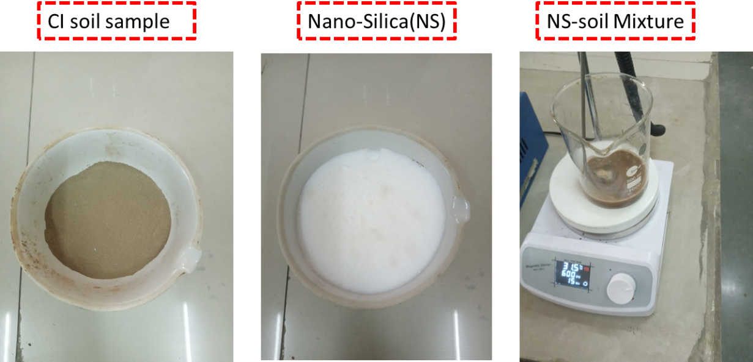

**Figure 1**: Materials Used in the Study

**Table 2:** Properties of soil

|  |  |
| --- | --- |
| **Parameters** | **Values** |
| LL | 36.25 |
| PL | 18.1 |
| PI | 18.15 |
| MDD | 14.52 |
| OMC | 21.32 |
| Sand (%) | 5.00% |
| Silt (%) | 35.00% |
| Clay (%) | 60.00% |
| Cu | 8.57 |
| Cc | 0.796 |
| Classification | CI |

**Table 3:** Properties of Nano-Silica

|  |  |
| --- | --- |
| **Properties** | **Values** |
| Purity | 99.0% |
| Average Particle Size | 40-60nm |
| Specific Surface Area | 500-685 m2/g |
| Bulk Density | 0.12 g/cm3 |
| Specific Gravity | 2.4g/cc3 |
| Colour | White |

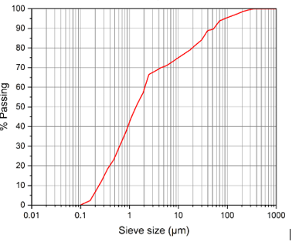

**Figure 2:** Soil sample's particle size distribution

|  |  |
| --- | --- |
|  | (a) |
|  | (b) |

**Figure 3:** Mohr circle of CU triaxial test (a) 0% NS at 0 days and (b) 4%NS at 90 days

|  |  |
| --- | --- |
|  | **(a)** |
|  | **(b)** |

**Figure 4:** (a) c(kpa) 0% to 4% from 0 to 90 days (b) Ø° 0% to 4% NS for 0 to 90 days

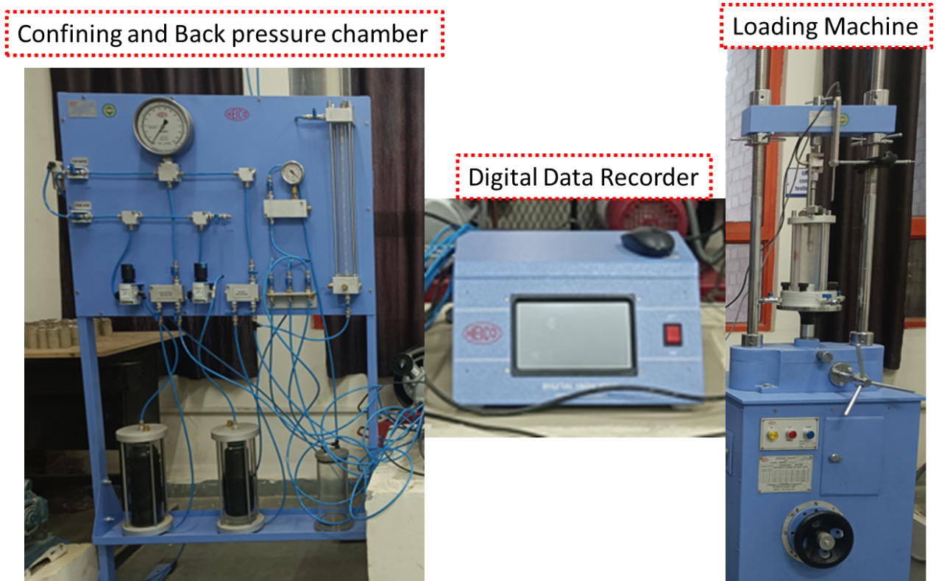

(a)

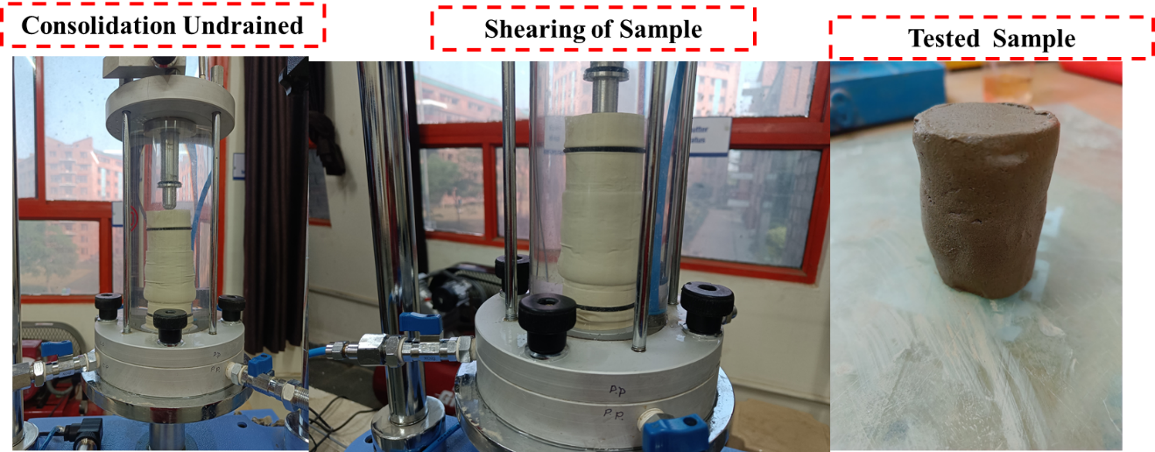

(b)

**Figure 5:** Experiment setup (a) Tri-axial setup (b) Sample testing used in the study

**3. Overview of Seismic Slope Stability Analysis Techniques**

Currently, there are three techniques used to assess a slope's stability in the event of an earthquake.

**3.1 Stress-Deformation Analysis for Seismic Slope Stability**

An essential technique for assessing a slope's stability is stress-deformation analysis, especially when dynamic loading conditions brought on by earthquakes are present. This technique evaluates the response of a slope's stresses and associated deformations to seismic activity, assisting engineers in anticipating possible failures and creating mitigating strategies (Tucho et al., 2022). The governing equations of motion for the slope material are first formulated, and these equations are frequently numerically solved using the finite element method (FEM). The dynamic equilibrium equation, which is stated as follows, is the fundamental formula used in stress-deformation analysis.

|  |  |
| --- | --- |
| {"mathml":"<math style=\"font-family:stix;font-size:16px;\" xmlns=\"http://www.w3.org/1998/Math/MathML\"><mstyle mathsize=\"16px\"><mi>M</mi><mi>&#xFC;</mi><mo>+</mo><mi>C</mi><mover><mi>u</mi><mo>&#x2D9;</mo></mover><mo>+</mo><mi>K</mi><mi>u</mi><mo>=</mo><mi>F</mi><mfenced><mi>t</mi></mfenced></mstyle></math>","origin":"MathType for Microsoft Add-in"} | (1) |

The acceleration vector, denoted by the word ü, describes how the slope material's velocity varies with time. The material's energy dissipation characteristics are reflected in the damping matrix, C, and the displacement change rate is shown by the velocity vector, $\dot{u}$. The displacement vector, u, represents the overall movement of the slope material, while the stiffness matrix, K, contains the material's resistance to deformation. The mass matrix is denoted by Mi. Lastly, the dynamic response of the slope is driven by time-dependent external pressures resulting from seismic activity, represented as F(t).

Discretizing the slope into finite elements and applying realistic initial and boundary conditions are the steps in the procedure. The exact deformation pattern of the slope is obtained by computing the dynamic reaction of each element over time, considering the interplay between stress and strain. Determining the soil or rock's yield stress and strain rates, which affect the damping and stiffness qualities, is an essential part of this investigation. The technique aids in the prediction of probable slip surfaces and zones of failure by integrating the seismic loading across time, making it possible to evaluate slope stability in the event of an earthquake (Yuan Zhang et al., 2022). In earthquake-prone areas, the safety and dependability of infrastructure are ensured by the design of stabilizing solutions, such as slope reinforcements, using the results of stress-deformation analysis. By considering the complex, dynamic character of seismic occurrences, this method surpasses simpler static analytic methodologies and offers a thorough knowledge of slope behavior.

**3.2 Newmark Permanent Displacement Method for Seismic Slope Deformation**

One popular technique for estimating the permanent deformation of slopes subjected to seismic loading is Newmark's permanent displacement analysis. This methodology computes the displacement that results from an earthquake's inertial forces surpassing the slope's resistive forces, treating the slope as if it were a rigid block lying on an inclined plane (Yang et al., 2024). The yield acceleration, or ay, which is the smallest horizontal acceleration needed to start slope movement, is a key idea in this technique. To calculate the velocity and slope displacement, the Newmark technique integrates the relative acceleration, a(t)−ay, across the course of the seismic event (Xue et al., 2023). The formula that governs is:

|  |  |
| --- | --- |
| {"mathml":"<math style=\"font-family:stix;font-size:16px;\" xmlns=\"http://www.w3.org/1998/Math/MathML\"><mstyle mathsize=\"16px\"><mi>D</mi><mo>=</mo><msubsup><mo>&#x222B;</mo><msub><mi>t</mi><mi>i</mi></msub><msub><mi>t</mi><mi>f</mi></msub></msubsup><msubsup><mo>&#x222B;</mo><msub><mi>t</mi><mi>i</mi></msub><mi>t</mi></msubsup><mfenced open=\"[\" close=\"]\"><mrow><mi>a</mi><mfenced><mi>t</mi></mfenced><mo>-</mo><msub><mi>a</mi><mi>y</mi></msub></mrow></mfenced><mo>d</mo><mi>t</mi><mi>d</mi><mi>t</mi></mstyle></math>","origin":"MathType for Microsoft Add-in"} | (2) |

where ti and tf are the beginning and ending times of the exceedance of ay, D is the permanent displacement, and a(t) is the acceleration time history of the earthquake.

By taking into consideration times when the seismic acceleration is greater than the yield acceleration, this double integration approach can capture the cumulative displacement. Engineers can better evaluate the possible risk and create suitable mitigation strategies to improve slope stability in the event of an earthquake by using the permanent displacement D that results. The simplicity and quantified assessment of slope deformation provided by Newmark's study make it useful for risk management.

**3.3 Pseudo-Static Method for Evaluating Seismic Slope Stability**

Through the simplification of dynamic earthquake forces into static equivalents, pseudo-static analysis is a technique used to assess the stability of slopes under seismic circumstances. The inertial forces caused by earthquakes are represented in this method by a constant horizontal seismic coefficient, *k*h (Yu Wang et al., 2022). These forces are then included in the equilibrium equations for the slope stability analysis, done using conventional static methods. By adjusting the driving and resisting forces appropriately, this method aids in determining the safety factor. Though it might not fully capture complex dynamic behaviors, the pseudo-static analysis offers an initial slope stability evaluation despite its simplicity.

One of the most commonly used methods for evaluating seismic resistance in clay is the pseudo-static approach (Aroni Hesari et al., 2022). The pseudo-static technique is suitable for both effective and total stress slope stability assessments and is simple to grasp. The seismic coefficient (*k*h), expressed as the earthquake force, is the earthquake force in the pseudo-static technique. It was Terzaghi (1950) who first used the pseudo-static approach. This method assumes that an additional static force is exerted on the slope, ignoring the dynamic feature of the earthquake. A lateral force working through the center of sliding mass and acting in the out-of-slope direction is applied in the pseudo-static technique (Çadır et al., 2021b) (Figure 6). Pseudo-static forces (*F*h and *F*v) in the horizontal and vertical directions can seem as follows:

|  |  |
| --- | --- |
| {"mathml":"<math style=\"font-family:stix;font-size:16px;\" xmlns=\"http://www.w3.org/1998/Math/MathML\"><mstyle mathsize=\"16px\"><msub><mi>F</mi><mi>h</mi></msub><mo>=</mo><mi>m</mi><mo>&#xD7;</mo><mi>a</mi><mo>=</mo><mfrac><mrow><mi>W</mi><mo>&#xD7;</mo><msub><mi>a</mi><mi>h</mi></msub></mrow><mi>g</mi></mfrac><mo>=</mo><mi>W</mi><mo>&#xD7;</mo><msub><mi>k</mi><mi>h</mi></msub></mstyle></math>","origin":"MathType for Microsoft Add-in"} | (3) |
| {"mathml":"<math xmlns=\"http://www.w3.org/1998/Math/MathML\" style=\"font-family:stix;font-size:16px;\"><msub><mi>F</mi><mi>v</mi></msub><mo>=</mo><mi>m</mi><mo>&#xD7;</mo><mi>a</mi><mo>=</mo><mfrac><mrow><mi>W</mi><mo>&#xD7;</mo><msub><mi>a</mi><mi>v</mi></msub></mrow><mi>g</mi></mfrac><mo>=</mo><mi>W</mi><mo>&#xD7;</mo><msub><mi>k</mi><mi>v</mi></msub></math>","origin":"MathType for Microsoft Add-in"} | (4) |

W is the total weight of the sliding material (kN), g is the gravitational acceleration (m/s2), *a*h, *a*v is the acceleration (the horizontal or vertical movements induced by the earthquake on the ground) (m/s2), and m represents the combined weight of the sliding substance (in kg), which is equivalent to W/g in scenarios three and four. Typically, the vertical pseudo-static force on the slope is usually disregarded because it affects both the holding and shifting forces.

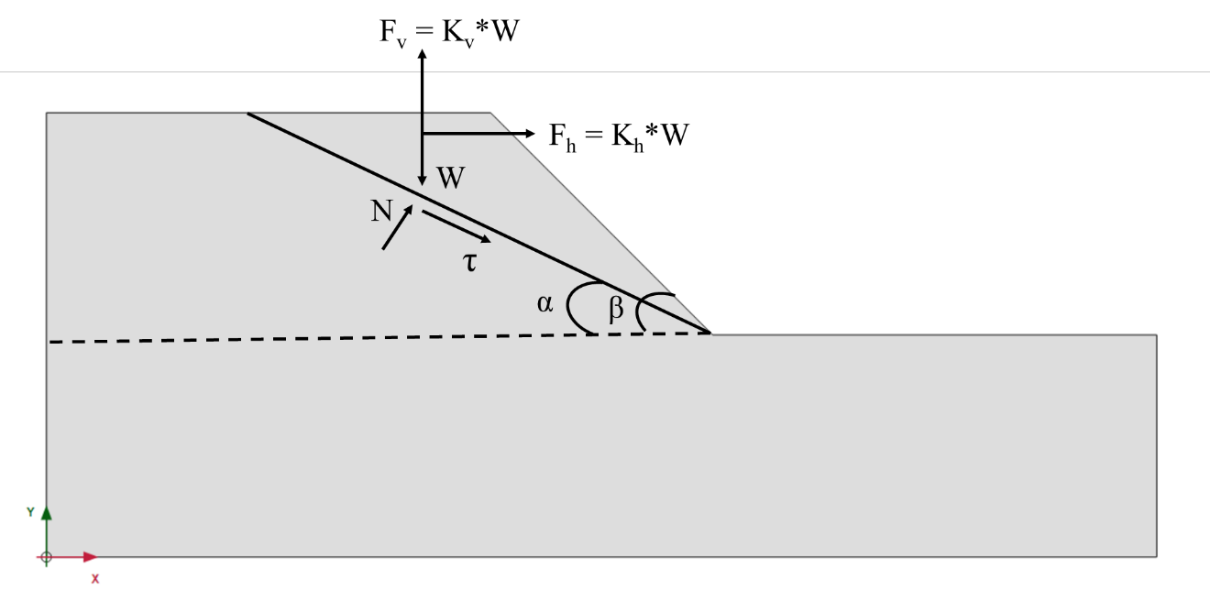

**Figure 6:** Force *F*h acting on slope’s center of gravity

Another crucial element of pseudo-static analysis involves calculating the slope's safety factor (5) when seismic forces are at play, by dissecting the forces affecting the slope failure mass along the surface of the failure (Duncan 1996; Kramer 1996).

|  |  |
| --- | --- |
| {"mathml":"<math style=\"font-family:stix;font-size:16px;\" xmlns=\"http://www.w3.org/1998/Math/MathML\"><mstyle mathsize=\"16px\"><mi>F</mi><mi>S</mi><mo>=</mo><mfrac><mrow><mi>c</mi><mfenced open=\"[\" close=\"]\"><mrow><mfenced><mrow><mi>W</mi><mo>-</mo><msub><mi>F</mi><mi>v</mi></msub></mrow></mfenced><mi>cos</mi><mi>&#x3B2;</mi><mo>-</mo><msub><mi>F</mi><mi>h</mi></msub><mi>sin</mi><mi>&#x3B2;</mi></mrow></mfenced><mi>tan</mi><mi>&#x3C6;</mi></mrow><mfenced open=\"[\" close=\"]\"><mrow><mfenced><mrow><mi>W</mi><mo>-</mo><msub><mi>F</mi><mi>v</mi></msub></mrow></mfenced><mi>sin</mi><mi>&#x3B2;</mi><mo>+</mo><msub><mi>F</mi><mi>h</mi></msub><mi>cos</mi><mi>&#x3B2;</mi></mrow></mfenced></mfrac></mstyle></math>","origin":"MathType for Microsoft Add-in"} | (5) |

The most crucial and challenging aspect of the analysis of pseudo-static stability is choosing an appropriate pseudo-static coefficient. Numerous scholars have offered recommendations about the choice of the pseudo-static coefficient, (Yeznabad et al., 2022; Yazdandoust et al., 2024; Macedo et al., 2020; Sadighi et al., 2022). It is feasible to conclude, after analyzing this research, that the pseudo-static coefficient was chosen through an engineering judgment based on a conventional application. Furthermore, the expected peak acceleration should align with a certain portion, and the pseudo-static coefficient needs to be calculated based on the anticipated acceleration in the slope's mass at failure (Chiou et al., 2024).

Since the pseudo-static method is similar to limit equilibrium analysis, it can be computed relatively easily. One must remember that choosing the pseudo-static coefficient and, thus, the dynamic inertia forces generated during the earthquake, will impact the accuracy of the safety factor obtained from this method (Zi-Long Zhang et al., 2021). The pseudo-static approach can offer a general and relative safety factor in slope stability tests affected by seismic forces, depending on the coefficient used (Lian-heng Zhao et al., 2020). Furthermore, according to (Jain et al., 2023), the pseudo-static approach can be used to pre-evaluate deformations caused by seismic loading and provide preliminary information in complex analyses.

The pseudo-static method was used in this study to evaluate the stability of slopes with and without stone columns during seismic events, considering the mentioned situations. The pseudo-static coefficient (*kh* = amax/g) for the pseudo-static analysis was determined using the maximum acceleration (amax). The 2015 Nepal earthquake's maximum acceleration value (Mw: 7.8) was utilized to determine the maximum acceleration. Table 4 displays the attributes of the Nepal earthquake, whereas Figure 4 illustrates the acceleration-time graph of the seismic event in the east-west direction. The maximum acceleration (amax) is 0.154 g, as shown in Figure 4. It was found that *k*h: 0.157 is the seismic coefficient that will be applied in the investigation. The *F*v force, and consequently the *k*v coefficient, were not considered in the study. In the investigation, the PLAXIS 2D finite element program was used to perform pseudo-static analyses. Safety factors were computed for slope models with and without stone columns under earthquake force using the estimated pseudo-static coefficient (*k*h: 0.157) in the PLAXIS 2D software.

**Table 4:** Characteristics of Nepal earthquake

|  |  |
| --- | --- |
| Location | Gorkha |
| Peak Ground Acceleration (g) | 0.154 |
| Epicentral distance | 85 km NW of central Kathmandu |
| Depth (km) | 15 |
| Magnitude (Mw) | 7.8 |
| Predominant period (s) | 5 |

PLAXIS 2D is a powerful finite element software specifically created for analyzing stability and deformation in geotechnical engineering and rock mechanics in two dimensions. Moreover, the PLAXIS finite element software can be easily used to consider different soil, boundary, and loading scenarios for assessing the stability of underground slopes in the short or long term, including water levels and various improvement techniques like additives, stone columns, piles, and geosynthetics (Chimdesa et al., 2023)

The stability of slopes is being investigated using PLAXIS 2D in the finite element approach, with failure defined similarly to the limit equilibrium method. The shear strength parameters (c and tan(ϕ)) are decreased until they reach the point of failure by utilizing the phi/c reduction method, which is a strength reduction approach, in the analysis of slope stability using the PLAXIS 2D software. The safety factor is computed in this instance using the formula (4). But remember that the network plays a critical role in accurately identifying the immigrants present in the slope.

|  |  |
| --- | --- |
| {"mathml":"<math style=\"font-family:stix;font-size:16px;\" xmlns=\"http://www.w3.org/1998/Math/MathML\"><mstyle mathsize=\"16px\"><mi>S</mi><mi>F</mi><mo>=</mo><mfrac><mrow><mi>a</mi><mi>v</mi><mi>a</mi><mi>i</mi><mi>l</mi><mi>a</mi><mi>b</mi><mi>l</mi><mi>e</mi><mo>&#xA0;</mo><mi>s</mi><mi>t</mi><mi>r</mi><mi>e</mi><mi>n</mi><mi>g</mi><mi>t</mi><mi>h</mi></mrow><mrow><mi>s</mi><mi>t</mi><mi>r</mi><mi>e</mi><mi>n</mi><mi>g</mi><mi>t</mi><mi>h</mi><mo>&#xA0;</mo><mi>f</mi><mi>a</mi><mi>i</mi><mi>l</mi><mi>u</mi><mi>r</mi><mi>e</mi></mrow></mfrac><mo>=</mo><mi>v</mi><mi>a</mi><mi>l</mi><mi>u</mi><mi>e</mi><mo>&#xA0;</mo><mi>o</mi><mi>f</mi><mo>&#x2211;</mo><mi>M</mi><mi>s</mi><mi>f</mi><mo>&#xA0;</mo><mi>a</mi><mi>t</mi><mo>&#xA0;</mo><mi>f</mi><mi>a</mi><mi>i</mi><mi>l</mi><mi>u</mi><mi>r</mi><mi>e</mi></mstyle></math>","origin":"MathType for Microsoft Add-in"} | (6) |

Surprisingly, by entering the provided value into the pseudo-static feature of the PLAXIS 2D finite element software, analyses can be carried out in gravity loading, plasticity, consolidation, and safety calculations. The pseudo-static parent phase can be subjected to a safety analysis. However, during the safety phase itself, it is not possible to specify a change in global accelerations. It is important to take into account the main phase parameters when conducting a safety analysis using Plaxis 2D Finite Element software from 1987. Upon reviewing previous studies, it was discovered that the analysis of slope stability using limit equilibrium methods resulted in calculated safety factors that were very close (Sumit Kumar et al., 2023b; Rao et al., 2024; Kassa et al., 2023).

**4 Finite Element Analysis of Seismic Slope Stability: Safety Factor, Horizontal Displacement, and the Impact of Nano-Silica Stabilization**

Using the PLAXIS finite element tool, the soil slopes were primarily modelled in two dimensions (2D). A slope with two layers of soil, angles of 30 and 45 degrees, heights of 6 and 12 meters, and widths of 30 and 36 meters, was simulated in the program's geometric model (Figure 7). The base soil layer had a height of 6 meters, resulting in total slope heights of 12 and 18 meters. The soil's cohesion and internal friction angle were determined through CU triaxial tests. In selecting the slope width and height, displacements and stress were both factored into consideration. Movement within the designated geometric slope models is limited in both horizontal (x-y) and vertical (x) directions as shown in Figure 7. Plane strain was employed to represent the slope-forming soil mass during the analyses. In addition, the program modelled soil behavior with the Mohr-Coulomb material model. The reason for selecting the Mohr-Coulomb material model is that, as shown in Table 5, it needs only five parameters, all commonly used in geotechnical engineering and easily determined through simple laboratory tests on soil samples. Once the slope geometry, material attributes, and required network input were provided, the slope model was prepared for analysis. Triangle elements with fifteen nodes make up the mesh used in the finite element calculation. The sample mesh details of the slope models are presented in Figure 8.

**Table 5:** Model Parameters

|  |  |  |  |  |
| --- | --- | --- | --- | --- |
| **Parameters** | **Symbols** | **Units** | **Upper Layer Soil** | **Lower Layer Soil** |
| Drainage Status | - | - | Undrained | Undrained |
| Unsaturated Unit weight | γunsat | (kN/m3) | 18.5 | 19.5 |
| Saturated Unit weight | γsat | (kN/m3) | 20.5 | 22.5 |
| Elasticity module | E | (kN/m2) | 15000 | 20000 |
| Poisson rate | ν | - | 0.3 | 0.33 |
| cohesion, c | c | (kN/m2) | 30 | 43.2 |
| Internal friction angle | ϕ | Degree (o) | 27.57 | 28.39 |

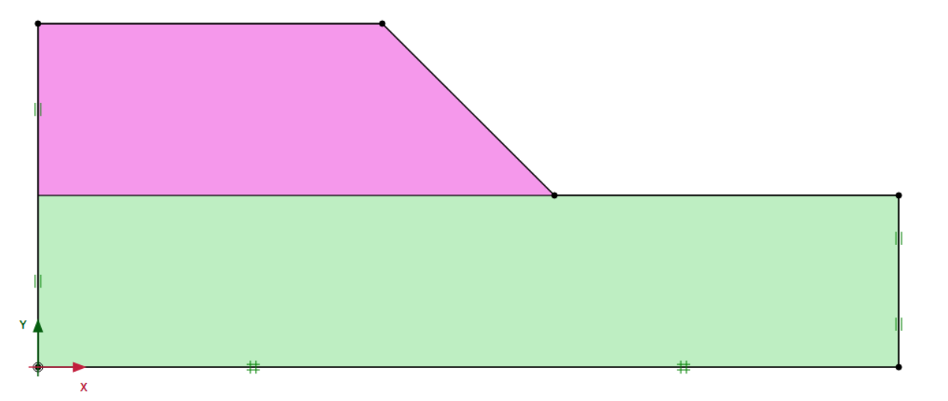

**Figure 7:** Formation of slope model

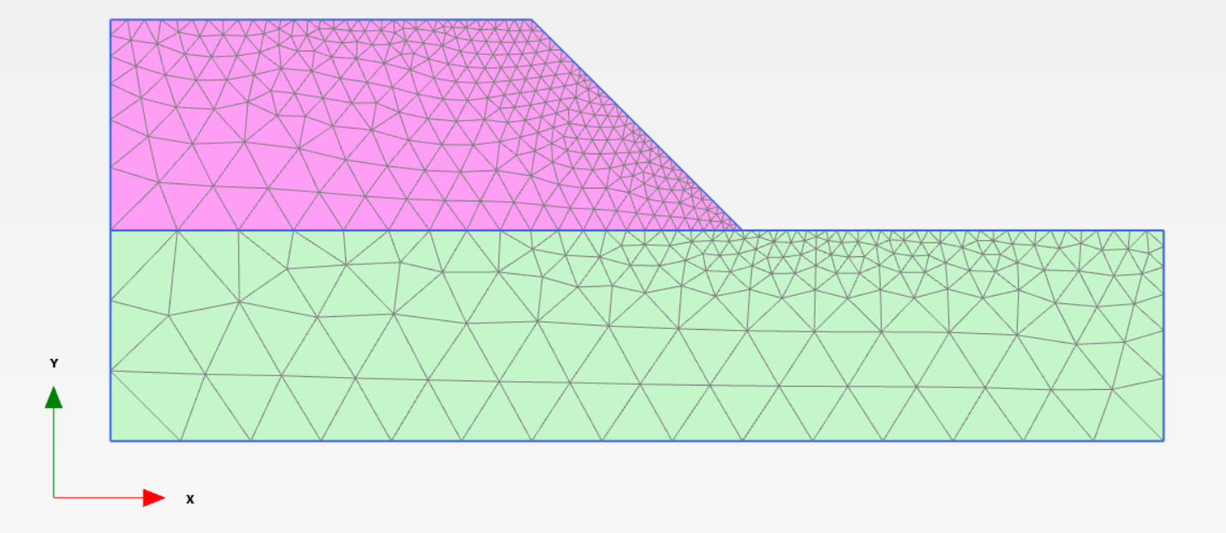

**Figure 8:** Mesh creation in slope models

In this section of the research, the *H*d values and safety factor of slopes, both stabilized and un-stabilized with NS, were determined under seismic force influence. In the Methodology section, it was demonstrated that the earthquake impact on the slope was simulated using the pseudo-static methodology in the PLAXIS 2D program. The research utilized the acceleration measurement recorded during the 2015 earthquake in Nepal. It was established that (*k*h) 0.157 is the seismic coefficient that will be applied in the investigation. In addition, Table 3 lists the earthquake's additional features.

In this stage of the study, the seismic coefficient (*k*h) value was included, which led to the determination of safety factor and *H*d values for slopes under the influence of earthquakes, both stabilized and un-stabilized with NS, through analysis. Figure 9 displays the final state of the slope following the analysis. Moreover, Tables 5, 6, and Figures. 10, 11 provide the safety factor and *H*d values after analyzing the slopes with and without NS stabilization.

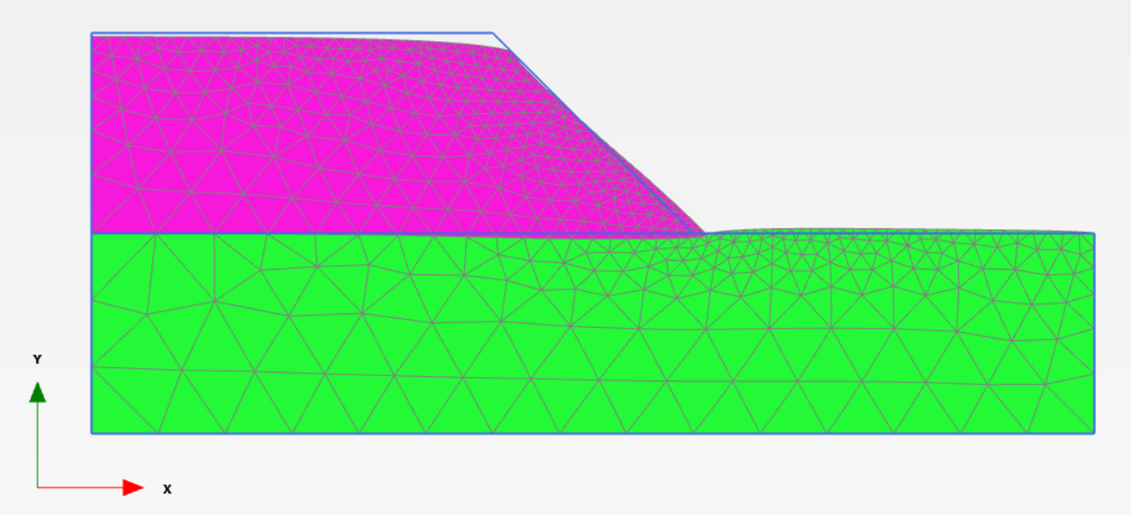

**Figure 9:** Slope models post-analysis status

**5 Assessment of SIF Under Seismic and Non-Seismic Loads**

Slope geometry, the soil structure that forms the slope, and the loads that affect the slope are the main components that influence the slope stability analysis. Therefore, stability charts produced through stability analysis techniques can be used in certain cases, particularly on evenly sloped surfaces. Fellinius incorporated stability cards to determine the safety factor value in slope stability assessments for the first time. Taylor and Janbu trailed behind Fellinius. Multiple researchers employed non-dimensional ratios of c/(γ.H) to reduce the number of variables in their parametric analyses on stability charts.

SIF values in this study section were determined by consulting several researches works. The SIF was computed by dividing the safety values of slopes stabilized with NS by the safety values of normal slopes under earthquake force. Tables 6 and 7 showcase the SIF values obtained under earthquake loading conditions.

**6 Results and Discussion**

**6.1 Experimental Results**

Unsaturated samples were used for the CU triaxial test. As a result, the diameter of the Mohr circles grows as the confining pressure value increases (Figure 3). With longer curing times (0, 45, and 90 days), Figure 10 displays the variation in cohesiveness and internal friction angle between non-stabilized and NS-stabilized samples with 0.5, 1.5, 3, and 4% NS, respectively. The cohesiveness and internal friction angle of the NS-treated samples both rise when NS is added to the soil. In comparison to the non-stabilized sample, the samples treated with 0.5, 1.5, 3 and 4% NS and cured for 90 days showed increases in cohesiveness of 173.73, 387.43, 515.53 and 820.63%, respectively. The samples that were cured for 90 days and stabilized with 0.5, 1.5, 3, and 4% NS similarly showed increases in their friction angle of around 3.33, 4.86, 8.23, and 11.49%, respectively. The percentage increase in cohesiveness and internal friction angle of NS stabilized soil over a prolonged curing period is shown in Figure 11. Thus, the strength and bearing capacity of NS-stabilized samples can be increased by increasing the compaction and cohesiveness between the soil particles. Chemical connections between soil particles are formed when NS is added to the soil. These connections create a cohesive substance that interlocks the soil particles to create a homogenous, integrated media.

|  |  |
| --- | --- |
| (a) | (b) |

**Figure 10:** (a) Cohesion and (b) internal friction angle of NS stabilized soil cured for an extended period

|  |  |
| --- | --- |
| (a) | (b) |

**Figure 11:** % increase of (a) Cohesion and (b) internal friction angle of NS stabilized soil cured for extended period

* 1. **FEM Analysis Result**

In this study, 52 assessments of slopes stabilized (48 models) and un-stabilized (four models) using NS were carried out while the force of an earthquake was applied. The slopes' FOS*, H*d, and SIF values were determined by the analyses. Tables 6, 7, and Figures 12 and 13 indicate that when earthquake force was considered, the FOS values of stabilized slopes (NS) were higher than those of un-stabilized slopes, with fixed c and ϕ values. Conversely, Tables 6 and 7 and Figures 12 and 13 from the analysis done for various doses of NS stabilized slopes show that FOS values decrease with increasing NS content. Comparing the *H*d values of NS stabilized and un-stabilized slopes during an earthquake, it was observed that the former had lower values of increased c and slope angle (β) compared to the latter. This is evident from Tables 6, 7, and Figures 14, 15. Conversely, NS content drops when *H*d values rise, according to Tables 6 and 7 and Figures 16, and 17, which show the results of analyses done for various NS stabilized slope dosages.

Analyzing the stress intensity factor values affected by seismic force reveals that the SIF values increased proportionally with a rise in the NS content. There was no noticeable change in the SIF readings when the slope height was adjusted. The SIF values rise in response to an increase in the soil's interior friction angle (ϕ). As the angle of slope (β) increased, a modest drop in the SIF values was noted. But for every model, there was no discernible linear rise or fall. In addition, a rise in soil c and φ resulted in higher SIF values, as evidenced by the graphs and tables.

**Table 6:** FOS, *H*d and SIF values of 30° slope

|  |  |  |  |  |  |  |  |  |
| --- | --- | --- | --- | --- | --- | --- | --- | --- |
| **H** | **Curing Days** | **NS (%)** | **c (kPa)** | **Ø°** | **FOS** | ***H*d (mm)** | **c/γH** | **SIF** |
| 6m | 0 day | 0 | 30.00 | 27.57 | 1.33 | 30.80 | 0.24 | 1.00 |
| 0.5 | 41.85 | 27.96 | 1.72 | 30.66 | 0.33 | 1.30 |
| 1.5 | 70.45 | 28.17 | 2.60 | 30.60 | 0.56 | 1.96 |
| 3 | 87.19 | 28.73 | 3.12 | 30.37 | 0.69 | 2.35 |
| 4 | 107.93 | 29.56 | 3.78 | 30.03 | 0.86 | 2.85 |
|  |  |  |  |  |  |  |  |
| 45 days | 0.5 | 76.38 | 28.17 | 2.78 | 30.59 | 0.61 | 2.10 |
| 1.5 | 123.73 | 28.61 | 4.24 | 30.40 | 0.98 | 3.20 |
| 3 | 163.82 | 29.21 | 5.47 | 30.22 | 1.30 | 4.13 |
| 4 | 239.91 | 30.23 | 7.73 | 29.86 | 1.90 | 5.83 |
|  |  |  |  |  |  |  |  |
| 90 days | 0.5 | 82.12 | 28.49 | 2.96 | 30.52 | 0.65 | 2.23 |
| 1.5 | 146.23 | 28.91 | 4.91 | 30.29 | 1.16 | 3.71 |
| 3 | 184.66 | 29.84 | 6.08 | 29.95 | 1.47 | 4.59 |
| 4 | 276.19 | 30.74 | 8.86 | 29.69 | 2.19 | 6.68 |
|  |  |  |  |  |  |  |  |  |
| 12m | 0 day | 0 | 30.00 | 27.57 | 0.82 | 86.74 | 0.12 | 1.00 |
| 0.5 | 41.85 | 27.96 | 1.14 | 86.22 | 0.17 | 1.38 |
| 1.5 | 70.45 | 28.17 | 1.67 | 85.92 | 0.28 | 2.04 |
| 3 | 87.19 | 28.73 | 1.98 | 85.31 | 0.35 | 2.41 |
| 4 | 107.93 | 29.56 | 2.36 | 84.52 | 0.43 | 2.87 |
|  |  |  |  |  |  |  |  |
| 45 days | 0.5 | 76.38 | 28.17 | 1.78 | 85.91 | 0.30 | 2.17 |
| 1.5 | 123.73 | 28.61 | 2.62 | 85.42 | 0.49 | 3.18 |
| 3 | 163.82 | 29.21 | 3.32 | 84.93 | 0.65 | 4.04 |
| 4 | 239.91 | 30.23 | 4.66 | 83.97 | 0.95 | 5.66 |
|  |  |  |  |  |  |  |  |
| 90 days | 0.5 | 82.12 | 28.49 | 1.89 | 85.54 | 0.33 | 2.30 |
| 1.5 | 146.23 | 28.91 | 3.02 | 84.96 | 0.58 | 3.67 |
| 3 | 184.66 | 29.84 | 3.70 | 84.26 | 0.73 | 4.50 |
| 4 | 276.19 | 30.74 | 5.30 | 83.41 | 1.10 | 6.45 |

**Table 7:** FOS, *H*d and SIF values of 45° slope

|  |  |  |  |  |  |  |  |  |
| --- | --- | --- | --- | --- | --- | --- | --- | --- |
| **H** | **Curing Days** | **NS (%)** | **c (kPa)** | **Ø°** | **FOS** | ***H*d (mm)** | **c/γH** | **SIF** |
| 6m | 0 day | 0 | 30.00 | 27.57 | 1.10 | 34.11 | 0.24 | 1.00 |
| 0.5 | 41.85 | 27.96 | 1.40 | 33.52 | 0.33 | 1.27 |
| 1.5 | 70.45 | 28.17 | 2.07 | 33.36 | 0.56 | 1.88 |
| 3 | 87.19 | 28.73 | 2.48 | 33.19 | 0.69 | 2.25 |
| 4 | 107.93 | 29.56 | 2.96 | 32.85 | 0.86 | 2.69 |
|  |  |  |  |  |  |  |  |
| 45 days | 0.5 | 76.38 | 28.17 | 2.22 | 33.31 | 0.61 | 2.02 |
| 1.5 | 123.73 | 28.61 | 3.31 | 33.22 | 0.98 | 3.01 |
| 3 | 163.82 | 29.21 | 4.22 | 32.96 | 1.30 | 3.84 |
| 4 | 239.91 | 30.23 | 5.96 | 32.52 | 1.90 | 5.42 |
|  |  |  |  |  |  |  |  |
| 90 days | 0.5 | 82.12 | 28.49 | 2.35 | 33.19 | 0.65 | 2.14 |
| 1.5 | 146.23 | 28.91 | 3.81 | 33.06 | 1.16 | 3.46 |
| 3 | 184.66 | 29.84 | 4.71 | 32.78 | 1.47 | 4.28 |
| 4 | 276.19 | 30.74 | 6.77 | 32.35 | 2.19 | 6.15 |
|  |  |  |  |  |  |  |  |  |
| 12m | 0 day | 0 | 30.00 | 27.57 | 0.62 | 212.50 | 0.12 | 1.00 |
| 0.5 | 41.85 | 27.96 | 0.84 | 143.60 | 0.17 | 1.35 |
| 1.5 | 70.45 | 28.17 | 1.38 | 94.11 | 0.28 | 2.23 |
| 3 | 87.19 | 28.73 | 1.62 | 93.36 | 0.35 | 2.61 |
| 4 | 107.93 | 29.56 | 1.92 | 92.39 | 0.43 | 3.10 |
|  |  |  |  |  |  |  |  |
| 45 days | 0.5 | 76.38 | 28.17 | 1.49 | 94.04 | 0.30 | 2.40 |
| 1.5 | 123.73 | 28.61 | 2.12 | 93.45 | 0.49 | 3.42 |
| 3 | 163.82 | 29.21 | 2.67 | 92.78 | 0.65 | 4.31 |
| 4 | 239.91 | 30.23 | 3.69 | 91.71 | 0.95 | 5.95 |
|  |  |  |  |  |  |  |  |
| 90 days | 0.5 | 82.12 | 28.49 | 1.59 | 93.60 | 0.33 | 2.56 |
| 1.5 | 146.23 | 28.91 | 2.43 | 92.91 | 0.58 | 3.92 |
| 3 | 184.66 | 29.84 | 2.96 | 92.06 | 0.73 | 4.77 |
| 4 | 276.19 | 30.74 | 4.18 | 91.11 | 1.10 | 6.74 |

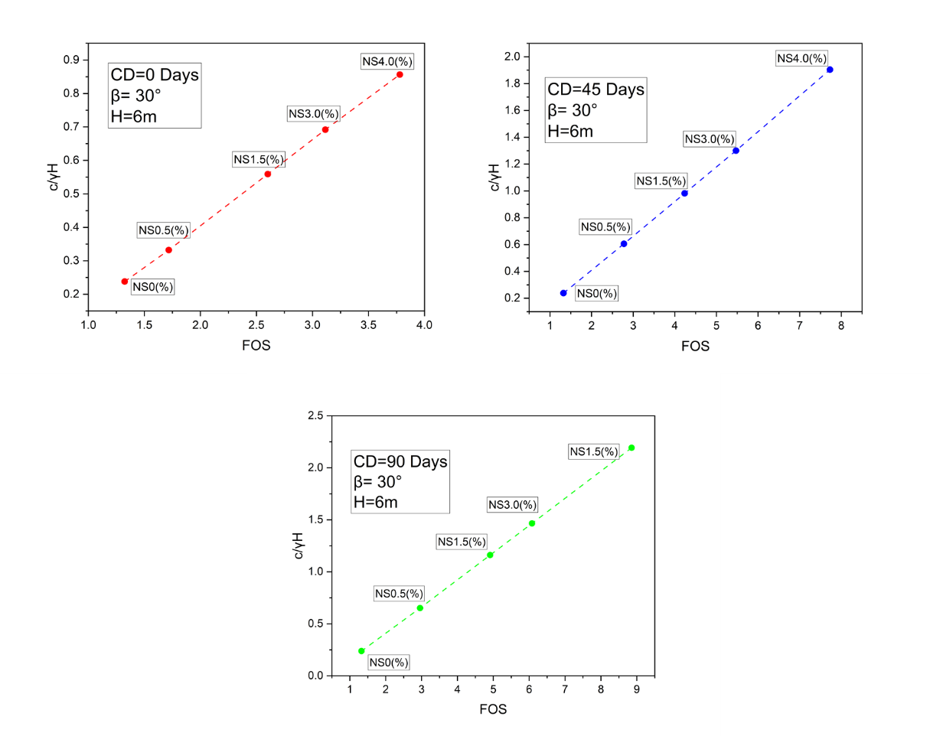

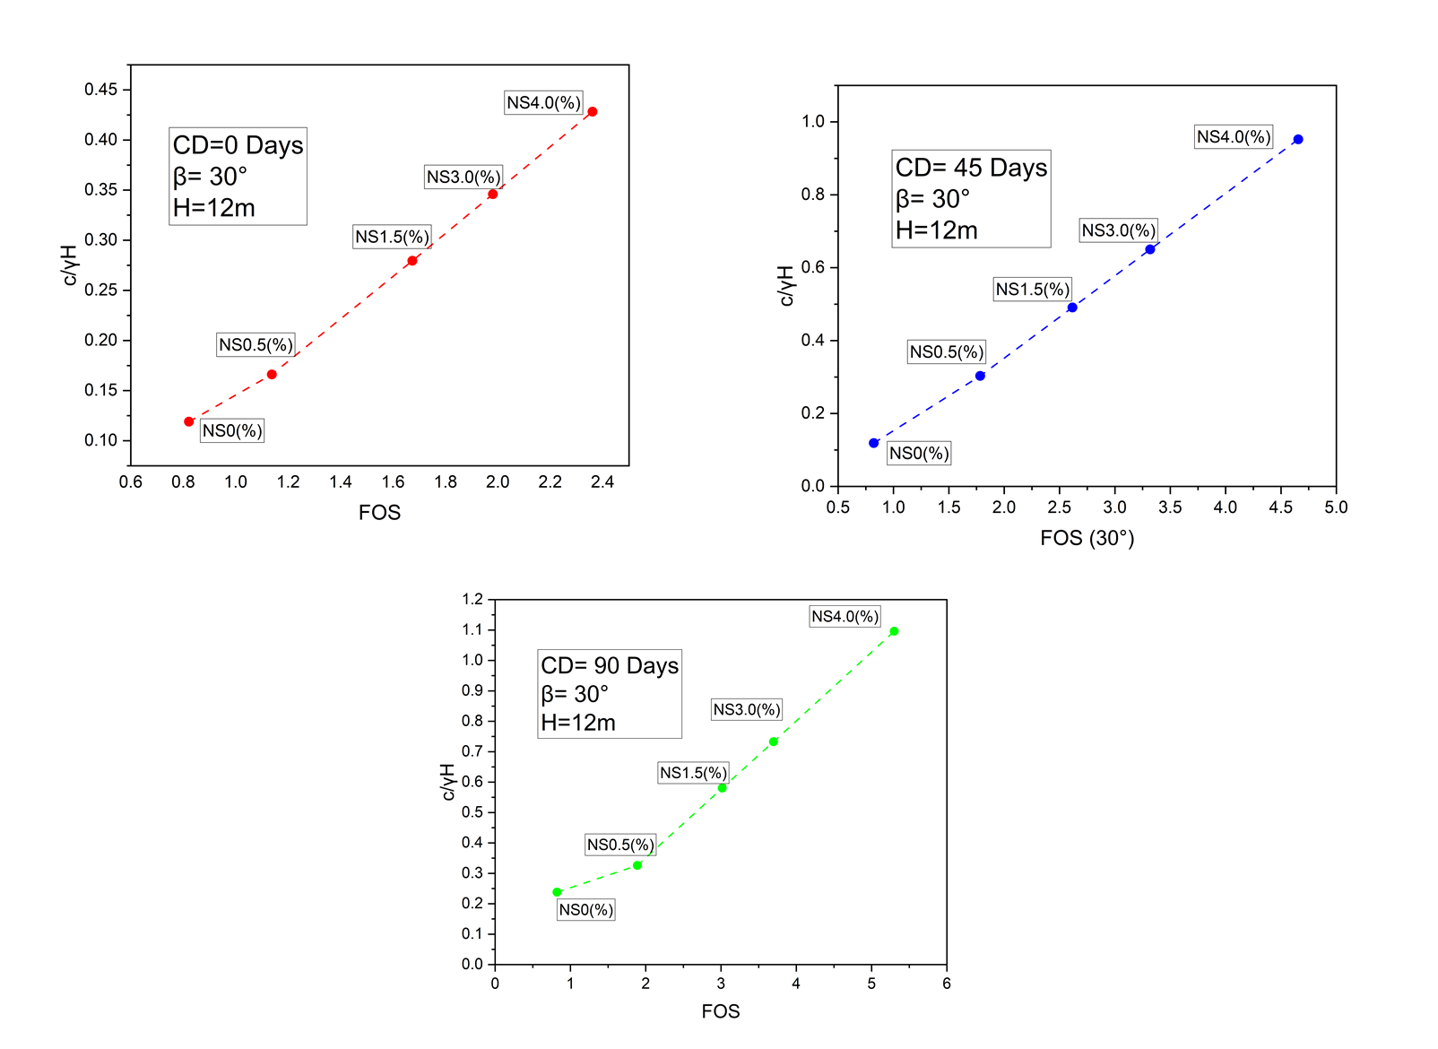

**Figure 12:** Change in FOS values (β = 30°)

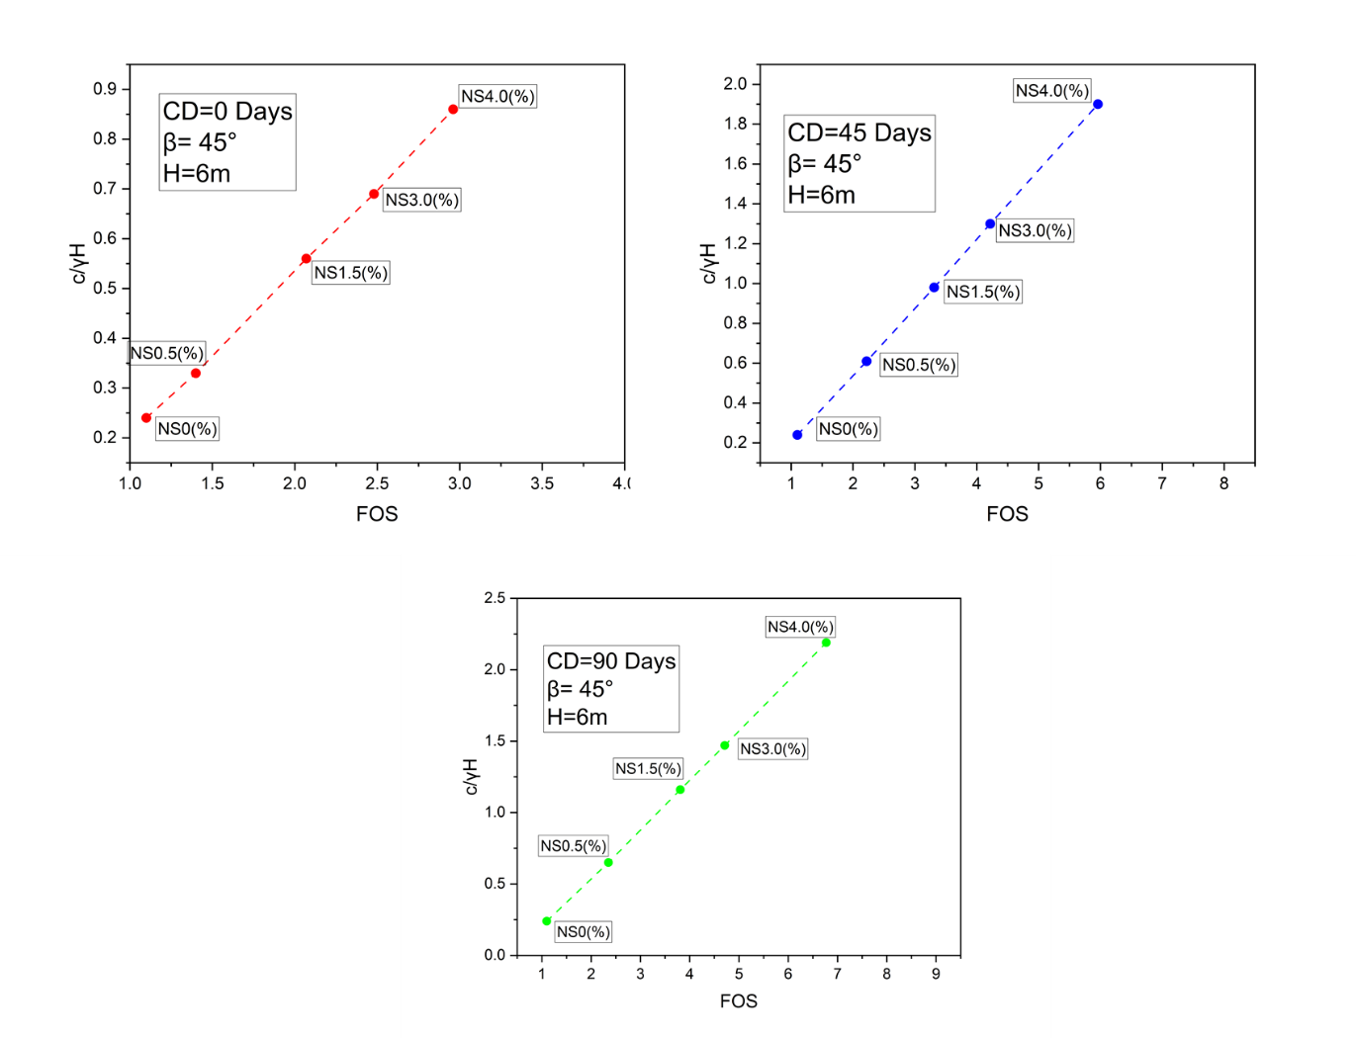

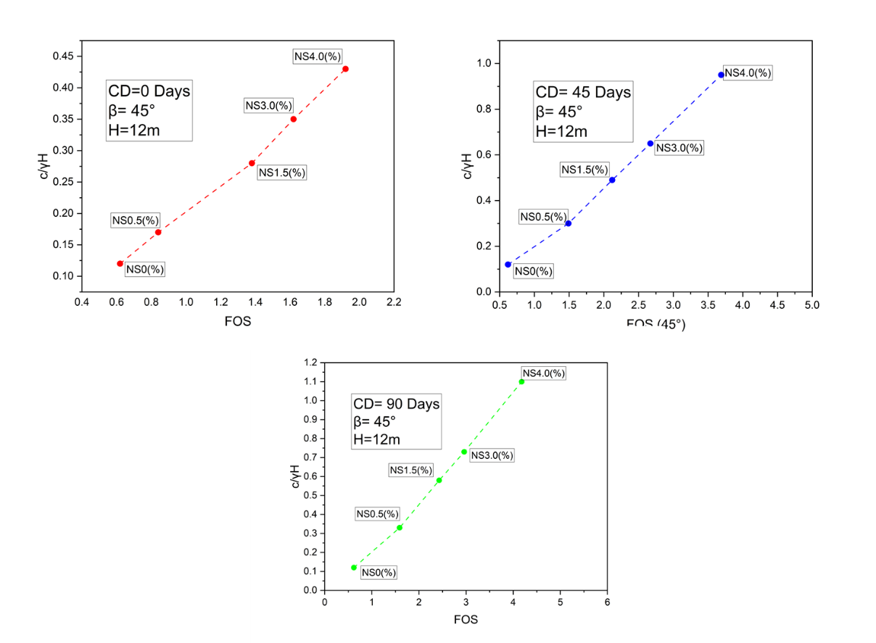

**Figure 13:** Change in FOS values (β = 45°)

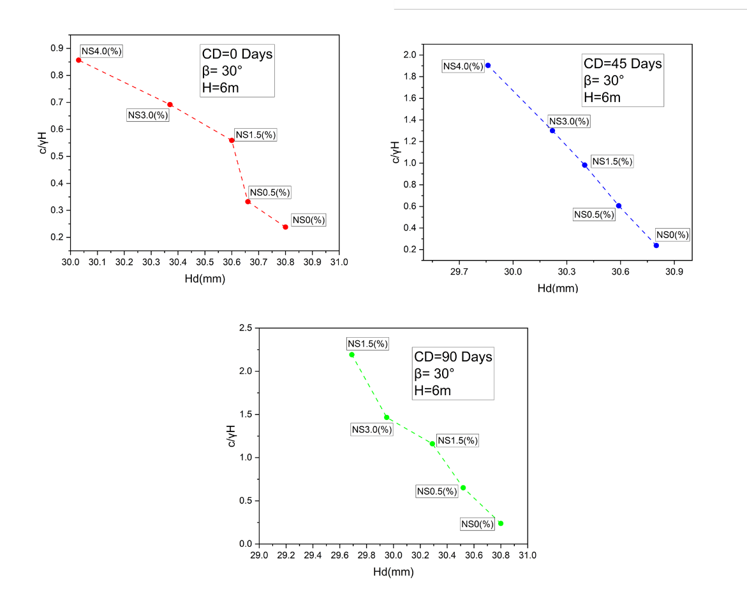

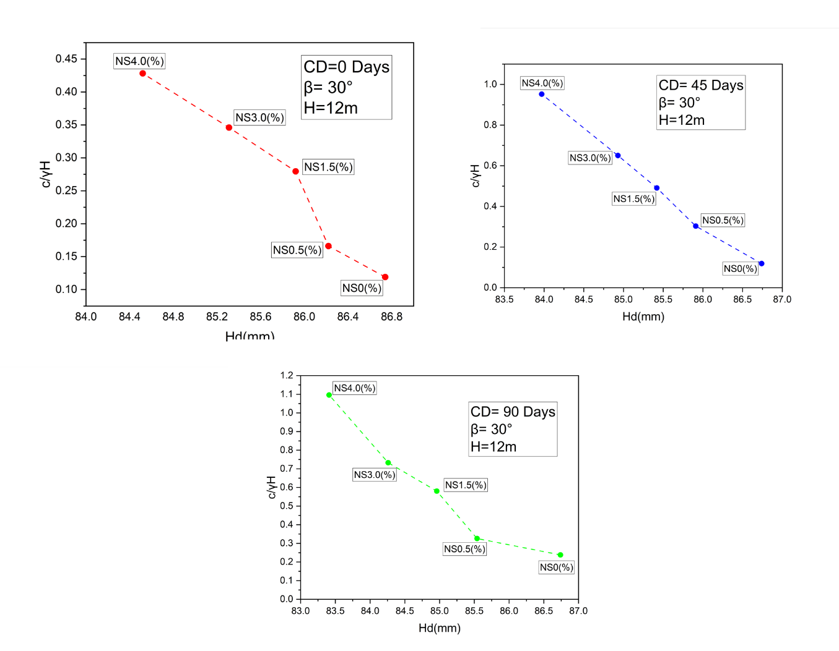

**Figure 14:** Change in *H*d values (β = 30°)

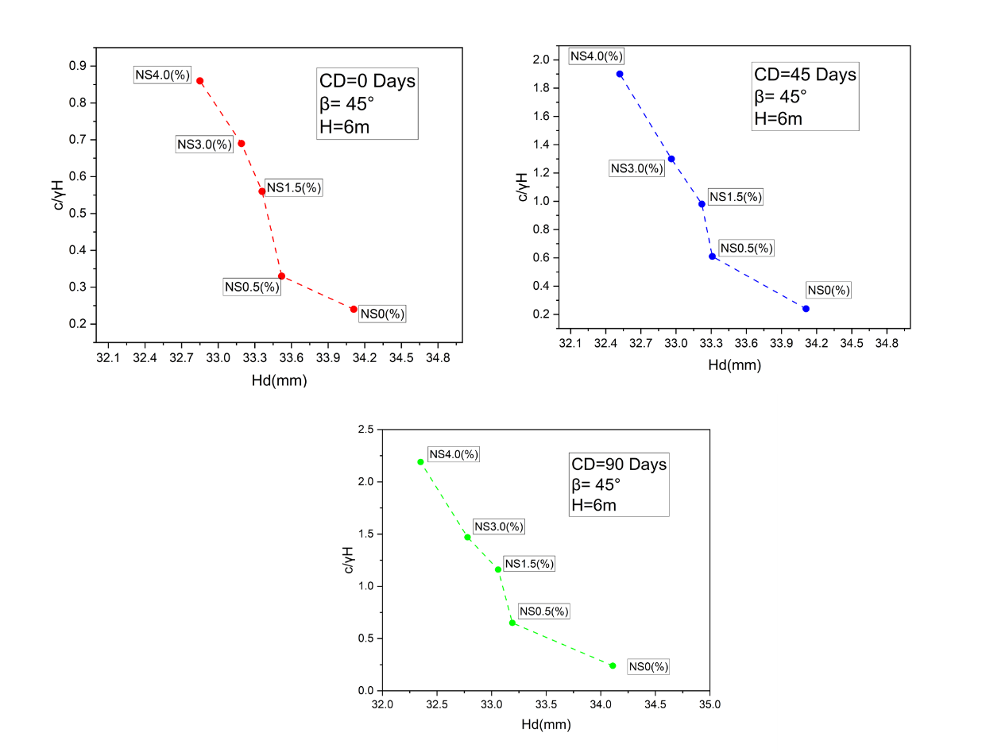

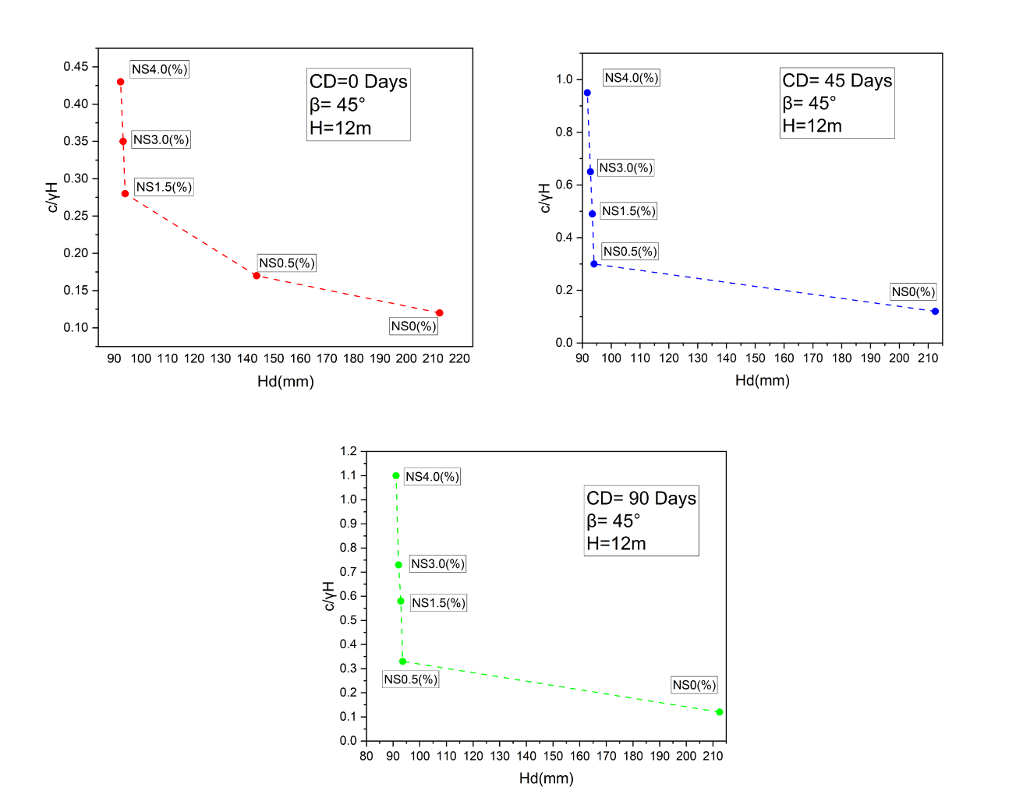

**Figure 15:** Change in *H*d values (β = 45°)

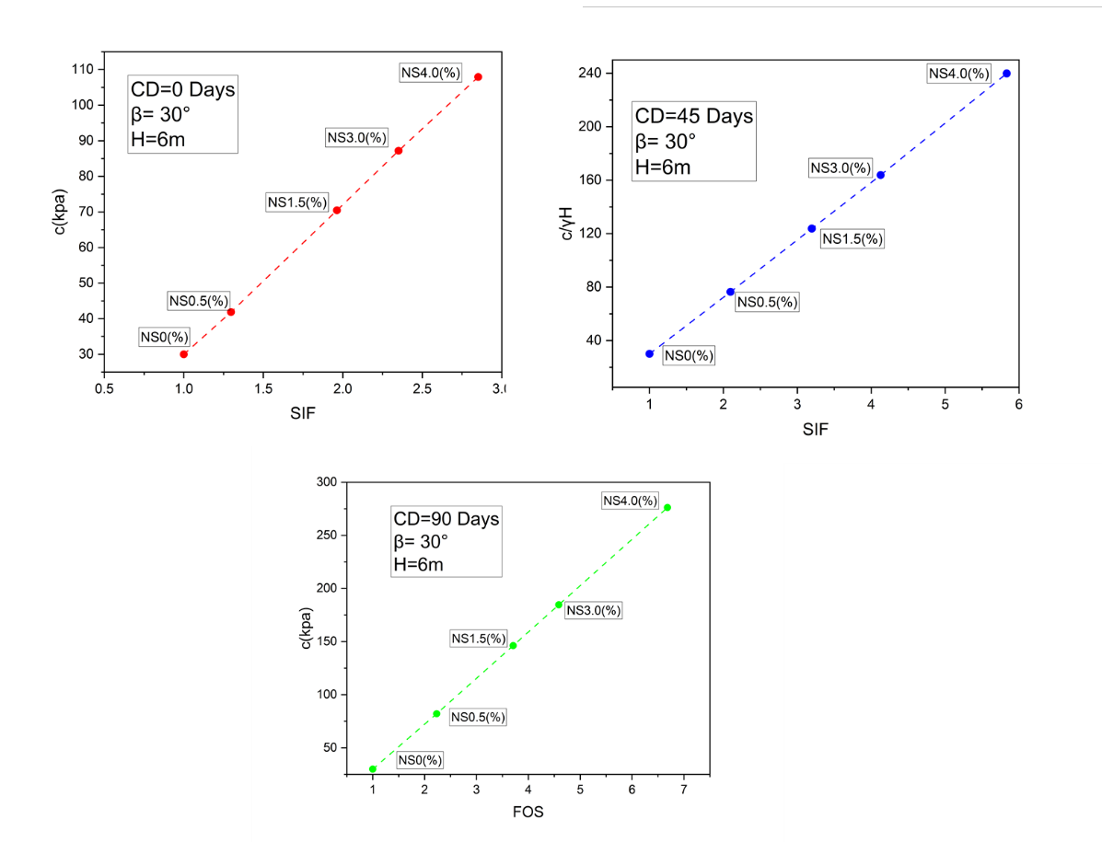

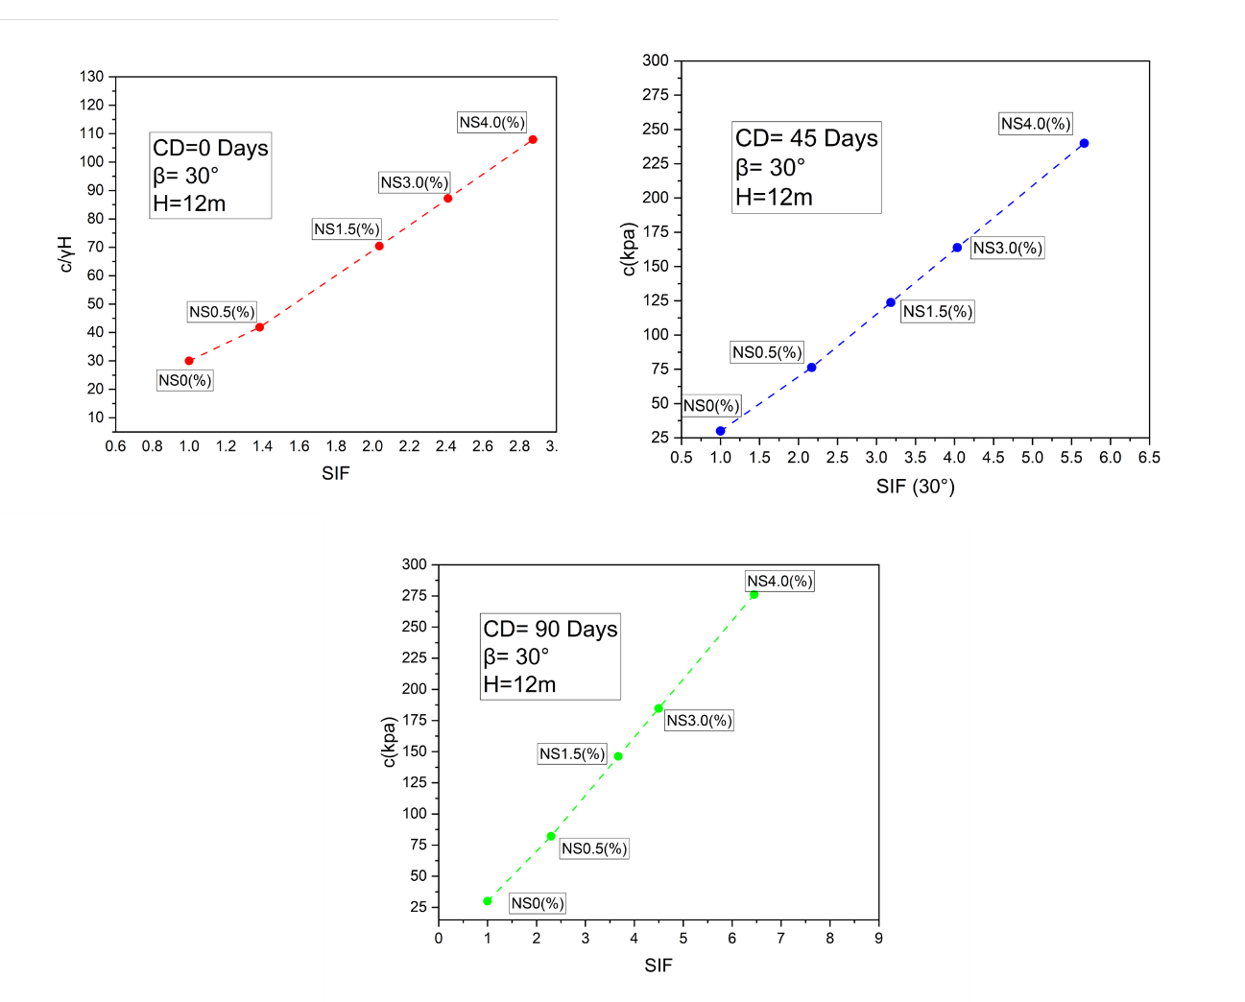

**Figure 16:** Change in SIF values (β = 30°)

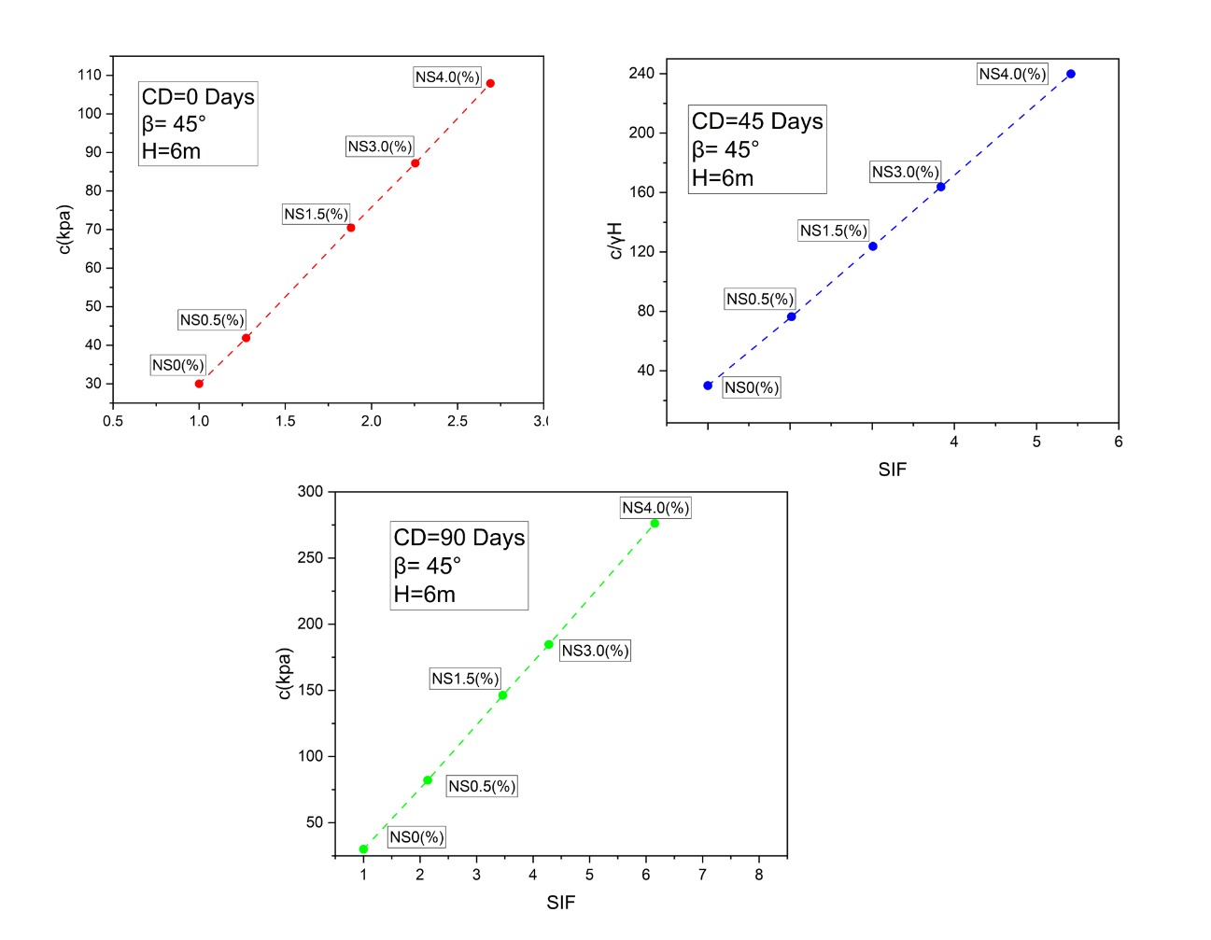

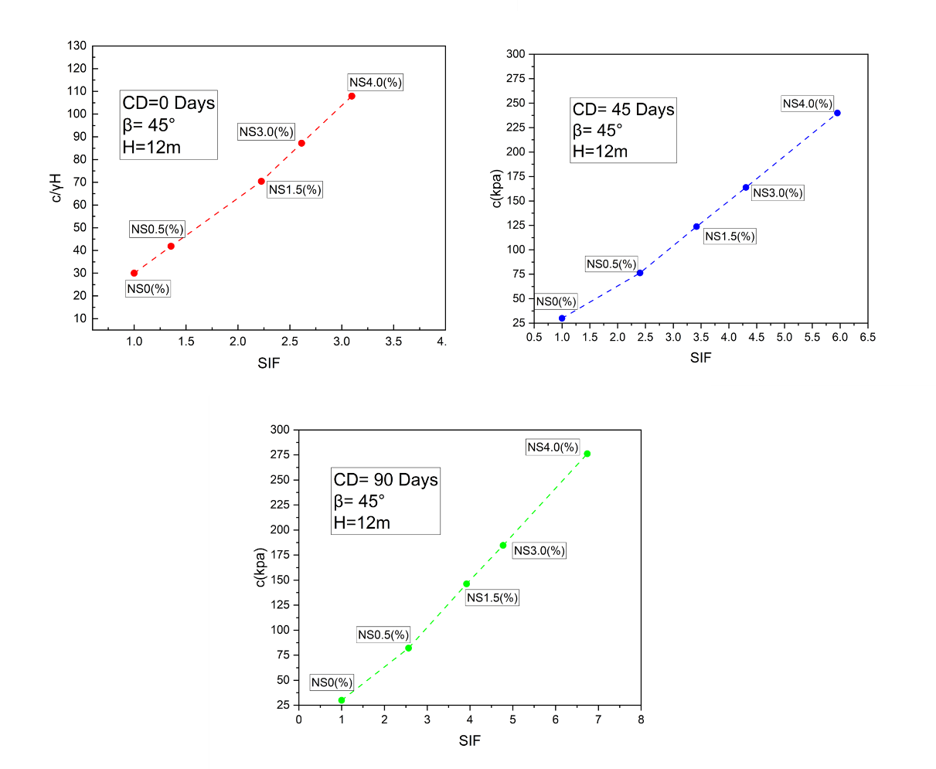

**Figure 17:** Change in SIF values (β = 45°)

* 1. **Comparison of FEM and Analytical FOS**

Tables 8 and 9 detail the comparison of FOS values produced by the FEM and analytical approaches, which shows significant variations under different situations for slope angles of 30° and 45°. Across a range of heights (6m and 12m), curing days (0, 45, and 90 days), and NS (%), it is clear that the FOS values produced via FEM are consistently larger than those obtained from the analytical models for both slope angles. Figure 18 illustrates the FOS comparison between FEM and the analytical model. In particular, the FEM technique exhibits a greater FOS increment as cohesion (c) and friction angle (Ø°) increase, especially as NS content and curing period rise. The difference between the FEM and analytical FOS values becomes much more noticeable at the steeper slope angle of 45° when this trend is more prominent. The FEM FOS is 8.86, for example, while the analytical FOS is 6.78 at β = 30°, H = 6m, and 90 days of curing with 4% NS. Comparably, under the same circumstances and with β = 45°, the analytical FOS is 4.86 and the FEM FOS is 6.77. In contrast to the more sophisticated and thorough FEM technique, which takes into consideration intricate interactions within the slope material, these discrepancies demonstrate the conservative character of analytical methods, which tend to underestimate the FOS.

**Table 8:** FOS values of the analytical equation and FEM for (β = 30°)

|  |  |  |  |  |  |  |
| --- | --- | --- | --- | --- | --- | --- |
| **H** | **Curing Days** | **NS (%)** | **c** | **Ø°** | **FEM FOS** | **Analytical FOS** |
| 6m | 0 day | 0 | 30.00 | 27.57 | 1.33 | 1.02 |
| 0.5 | 41.85 | 27.96 | 1.72 | 1.34 |
| 1.5 | 70.45 | 28.17 | 2.60 | 1.83 |
| 3 | 87.19 | 28.73 | 3.12 | 2.41 |
| 4 | 107.93 | 29.56 | 3.78 | 2.71 |
|  |  |  |  |  |  |
| 45 days | 0.5 | 76.38 | 28.17 | 2.78 | 2.08 |
| 1.5 | 123.73 | 28.61 | 4.24 | 3.43 |
| 3 | 163.82 | 29.21 | 5.47 | 4.36 |
| 4 | 239.91 | 30.23 | 7.73 | 6.58 |
|  |  |  |  |  |  |
| 90 days | 0.5 | 82.12 | 28.49 | 2.96 | 2.38 |
| 1.5 | 146.23 | 28.91 | 4.91 | 3.85 |
| 3 | 184.66 | 29.84 | 6.08 | 4.54 |
| 4 | 276.19 | 30.74 | 8.86 | 6.78 |
|  |  |  |  |  |  |  |
| 12 | 0 day | 0 | 30.00 | 27.57 | 0.82 | 0.69 |
| 0.5 | 41.85 | 27.96 | 1.14 | 0.93 |
| 1.5 | 70.45 | 28.17 | 1.67 | 1.22 |
| 3 | 87.19 | 28.73 | 1.98 | 1.49 |
| 4 | 107.93 | 29.56 | 2.36 | 1.92 |
|  |  |  |  |  |  |
| 45 days | 0.5 | 76.38 | 28.17 | 1.78 | 1.40 |
| 1.5 | 123.73 | 28.61 | 2.62 | 1.96 |
| 3 | 163.82 | 29.21 | 3.32 | 2.47 |
| 4 | 239.91 | 30.23 | 4.66 | 3.54 |
|  |  |  |  |  |  |
| 90 days | 0.5 | 82.12 | 28.49 | 1.89 | 1.61 |
| 1.5 | 146.23 | 28.91 | 3.02 | 2.56 |
| 3 | 184.66 | 29.84 | 3.70 | 2.79 |
| 4 | 276.19 | 30.74 | 5.30 | 4.22 |

**Table 9:** FOS values of the analytical equation and FEM for (β = 45°)

|  |  |  |  |  |  |  |
| --- | --- | --- | --- | --- | --- | --- |
| **H** | **Curing Days** | **NS (%)** | **c (kPa)** | **Ø°** | **FEM FOS** | **Analytical FOS** |
| 6m | 0 day | 0 | 30 | 27.57 | 1.1 | 0.85 |
| 0.5 | 41.85 | 27.96 | 1.4 | 1.17 |
| 1.5 | 70.45 | 28.17 | 2.07 | 1.49 |
| 3 | 87.19 | 28.73 | 2.48 | 1.75 |
| 4 | 107.93 | 29.56 | 2.96 | 2.15 |
|  |  |  |  |  |  |
| 45 days | 0.5 | 76.38 | 28.17 | 2.22 | 1.81 |
| 1.5 | 123.73 | 28.61 | 3.31 | 2.49 |
| 3 | 163.82 | 29.21 | 4.22 | 3.41 |
| 4 | 239.91 | 30.23 | 5.96 | 5.05 |
|  |  |  |  |  |  |
| 90 days | 0.5 | 82.12 | 28.49 | 2.35 | 1.77 |
| 1.5 | 146.23 | 28.91 | 3.81 | 2.88 |
| 3 | 184.66 | 29.84 | 4.71 | 3.58 |
| 4 | 276.19 | 30.74 | 6.77 | 4.86 |
|  |  |  |  |  |  |  |
| 12m | 0 day | 0 | 30 | 27.57 | 0.62 | 0.45 |
| 0.5 | 41.85 | 27.96 | 0.84 | 0.68 |
| 1.5 | 70.45 | 28.17 | 1.38 | 1.05 |
| 3 | 87.19 | 28.73 | 1.62 | 1.21 |
| 4 | 107.93 | 29.56 | 1.92 | 1.41 |
|  |  |  |  |  |  |
| 45 days | 0.5 | 76.38 | 28.17 | 1.49 | 1.24 |
| 1.5 | 123.73 | 28.61 | 2.12 | 1.51 |
| 3 | 163.82 | 29.21 | 2.67 | 2.09 |
| 4 | 239.91 | 30.23 | 3.69 | 3.01 |
|  |  |  |  |  | 0.00 |
| 90 days | 0.5 | 82.12 | 28.49 | 1.59 | 1.14 |
| 1.5 | 146.23 | 28.91 | 2.43 | 2.05 |
| 3 | 184.66 | 29.84 | 2.96 | 2.31 |
| 4 | 276.19 | 30.74 | 4.18 | 3.34 |

|  |  |
| --- | --- |
|  | **(a)** |
|  | **(b)** |

**Figure 18:** FOS comparison between FEM and analytical (a) β = 30° and (b) β = 45°

**7. Reliability Analysis**

Verifying the scant field data utilized in decision-making requires the application of mathematical modelling and prediction (Liu et al., 2023; Yazdi, 2024). This procedure usually entails gathering already-existing laboratory data, utilizing these equations for forecasting and prediction, and developing relationships for problematic soil by fitting mathematical formulas to experimental outcomes. But uncertainty exists in practically every engineering discipline, including geotechnical engineering (Jiang et al., 2023; Ze Zhou Wang et al., 2023; Hongbo Zhao et al., 2024). The significance of probabilistic techniques for geotechnical structure analysis has been brought to light by the growing frequency of failures in these structures and their severe negative effects (Chwała et al., 2023). Because of this, probabilistic techniques are being used more and more by geotechnical engineers to account for uncertainty and enhance the accuracy of their analyses. Problematic soi can cause geotechnical structures to fail, and treating soil with expandable binders might result in an unfeasible design. An affordable and sustainable solution may result from stabilizing problematic soil with NS. On the other hand, a great deal of uncertainty is noted regarding the characteristics of NS-stabilized soils. Several variables, including the uneven distribution of NS particles, the kind and durability of the NS, the presence of water, acids, and alkalis in the soil, and the interaction between soil particles and NS, might cause uncertainties in the strength response of soils treated with NS. A decline in the stabilization's efficiency could result from all of these factors. Therefore, for the safe design of the sub-base, it is imperative to consider the significant degree of variability associated with the strength parameters in a sensible manner. A well-known mathematical method for estimating the uncertainties related to the randomness of such field variables is reliability analysis. Moghal et al. (2017, 2018) reported the target reliability approach to study the Effect of PPF-reinforced lime-treated soil on UCS and CBR. Sudhakaran et al. (2018) predicted the reliability index values against rutting and fatigue failure of chemically treated coir fiber in cement-bottom ash mixed soil. Syed and GuhaRay (2020) validated the geomechanical strength parameters of polypropylene and glass fibre-reinforced alkaline soil by proving with least probability of failure (*P*f) against compressive shear, tensile, and durability of fibre-AAB-soil mixtures.

In this context, it is considered the cumulative distribution function (CDF) F(x), which represents the probability that a random variable X (such as the time to failure) is less than or equal to a certain value x. The *P*f​ is then simply the value of this cumulative distribution function. The reliability function R(x) represents the probability that the system has not failed up to a value x, and it is related to the CDF by:

|  |  |
| --- | --- |
| {"mathml":"<math style=\"font-family:stix;font-size:16px;\" xmlns=\"http://www.w3.org/1998/Math/MathML\"><mstyle mathsize=\"16px\"><mi>R</mi><mfenced><mi>x</mi></mfenced><mo>=</mo><mn>1</mn><mo>-</mo><mi>F</mi><mfenced><mi>x</mi></mfenced></mstyle></math>","origin":"MathType for Microsoft Add-in"} | (7) |

Therefore, the probability of failure Pf can be expressed as:

|  |  |
| --- | --- |
| {"mathml":"<math style=\"font-family:stix;font-size:16px;\" xmlns=\"http://www.w3.org/1998/Math/MathML\"><mstyle mathsize=\"16px\"><mi>P</mi><mi>f</mi><mo>=</mo><mi>F</mi><mfenced><mi>x</mi></mfenced></mstyle></math>","origin":"MathType for Microsoft Add-in"} | (8) |

Given that, we have:

|  |  |
| --- | --- |
| {"mathml":"<math xmlns=\"http://www.w3.org/1998/Math/MathML\" style=\"font-family:stix;font-size:16px;\"><mi>P</mi><mi>f</mi><mo>=</mo><mn>1</mn><mo>-</mo><mi>R</mi><mfenced><mi>x</mi></mfenced></math>","origin":"MathType for Microsoft Add-in"} | (9) |

In cases where the specific form of F(x) is known, such as with an exponential distribution where{"mathml":"<math xmlns=\"http://www.w3.org/1998/Math/MathML\" style=\"font-family:stix;font-size:16px;\"/>","origin":"MathType for Microsoft Add-in"}{"mathml":"<math style=\"font-family:stix;font-size:16px;\" xmlns=\"http://www.w3.org/1998/Math/MathML\"><mstyle mathsize=\"16px\"><mi>F</mi><mfenced><mi>x</mi></mfenced><mo>=</mo><mn>1</mn><mo>-</mo><msup><mi>e</mi><mrow><mo>-</mo><mi>&#x3BB;</mi><mi>x</mi></mrow></msup></mstyle></math>","origin":"MathType for Microsoft Add-in"}, the probability of failure is given directly by:

|  |  |
| --- | --- |
| {"mathml":"<math style=\"font-family:stix;font-size:16px;\" xmlns=\"http://www.w3.org/1998/Math/MathML\"><mstyle mathsize=\"16px\"><mi>P</mi><mi>f</mi><mo>=</mo><mn>1</mn><mo>-</mo><msup><mi>e</mi><mrow><mo>-</mo><mi>&#x3BB;</mi><mi>x</mi></mrow></msup></mstyle></math>","origin":"MathType for Microsoft Add-in"} | (10) |

**7.1 Regression Model**

Regression models are used in statistical contexts to establish a relationship between dependent and independent variables. A parabolic non-linear regression equation was used in this study to express the effects of various NS dosages on FOS and Hd. This model estimates the unknown parameters and efficiently captures the experiment outcomes with huge datasets. The following are the parabolic equations that best suit the data to forecast the FOS and Hd of NS stabilized soil slope with R2 of 0.98 and 0.82 in equations 11 and 12 respectively

|  |  |
| --- | --- |
| {"mathml":"<math style=\"font-family:stix;font-size:16px;\" xmlns=\"http://www.w3.org/1998/Math/MathML\"><mstyle mathsize=\"16px\"><mi>F</mi><mi>O</mi><mi>S</mi><mo>=</mo><mn>4</mn><mo>.</mo><mn>287</mn><mo>-</mo><mn>0</mn><mo>.</mo><mn>049</mn><mi>&#x3B2;</mi><mo>-</mo><mn>0</mn><mo>.</mo><mn>014</mn><mi>H</mi><mo>+</mo><mn>0</mn><mo>.</mo><mn>001</mn><mi>C</mi><mi>D</mi><mo>+</mo><mn>0</mn><mo>.</mo><mn>059</mn><mi>N</mi><mi>S</mi><mfenced><mo>%</mo></mfenced><mo>+</mo><mn>0</mn><mo>.</mo><mn>005</mn><mi>c</mi><mo>-</mo><mn>0</mn><mo>.</mo><mn>071</mn><mi>&#x3C6;</mi><mo>&#xB0;</mo><mo>+</mo><mn>2</mn><mo>.</mo><mn>707</mn><mi>c</mi><mo>/</mo><mi>&#x3B3;</mi><mi>H</mi></mstyle></math>","origin":"MathType for Microsoft Add-in"} | (11) |

|  |  |
| --- | --- |
| {"mathml":"<math style=\"font-family:stix;font-size:16px;\" xmlns=\"http://www.w3.org/1998/Math/MathML\"><mstyle mathsize=\"16px\"><mi>H</mi><mi>d</mi><mo>=</mo><mo>-</mo><mn>442</mn><mo>.</mo><mn>967</mn><mo>+</mo><mn>0</mn><mo>.</mo><mn>787</mn><mi>&#x3B2;</mi><mo>+</mo><mn>13</mn><mo>.</mo><mn>237</mn><mi>H</mi><mo>-</mo><mn>0</mn><mo>.</mo><mn>242</mn><mi>C</mi><mi>D</mi><mo>-</mo><mn>11</mn><mo>.</mo><mn>186</mn><mi>N</mi><mi>S</mi><mfenced><mo>%</mo></mfenced><mo>-</mo><mn>0</mn><mo>.</mo><mn>162</mn><mi>c</mi><mo>+</mo><mn>13</mn><mo>.</mo><mn>412</mn><mi>&#x3C6;</mi><mo>&#xB0;</mo><mo>+</mo><mn>31</mn><mo>.</mo><mn>315</mn><mi>c</mi><mo>/</mo><mi>&#x3B3;</mi><mi>H</mi></mstyle></math>","origin":"MathType for Microsoft Add-in"} | (12) |

The FOS and Hd observation points closely align with the FEM results based on the nonlinear regression equation proposed for NS-stabilized fine-grained soil. Construction experts can utilize the proposed equation to determine the necessary dosage of NS based on their specified design strength value.

**7.2 Monte Carlo Simulation for Probability of Failure**

The likelihood of failure for the FOS of the soil sample was estimated using the Monte Carlo simulation. The outcomes of a Monte Carlo simulation used to determine the probability of failure (*P*f) for the FOS of soil sample samples are shown in Figure 19. Using the normal distribution defined by the computed mean and standard deviation, the simulation creates a simulated FOS value every 30,000 iterations. Each simulated FOS value is compared to a predetermined failure criterion (in this case, FOS < 1) by the code. To calculate the failure frequency, the simulated FOS values are counted as many times as they fall below this threshold.

Statistical modelling and repeated random sampling are combined in a systematic way in the Monte Carlo simulation to estimate the *P*f for the FOS of soil samples. To estimate the *P*f for the FOS of soil samples, a Monte Carlo simulation is shown in Figure 18. Initially, the simulation process defines the important variables: the specified failure threshold (T), the number of simulations (N), which is 30,000 in this case, and the mean (μ) and standard deviation (σ) of the FOS values. Using the given mean and standard deviation, each of these simulations produces a FOS value that is presumed to follow a normal distribution.

A simulated FOS value (Xi) is taken from this normal distribution, N (μ, σ), for each of the 30,000 repetitions. By taking this step, the simulation is guaranteed to depict the variety in the FOS values appropriately. The next stage is to determine if each simulated FOS value is less than the 1 kg/cm^ failure threshold (T). An indicator function I is used for this check; it equals 1 in the case that the simulated value is below the threshold and 0 in the other case. Next, the number of failures (F) is calculated by adding up the indicator function's output for each iteration. The total number of simulated FOS values that fall below the failure threshold is indicated by this total. Lastly, the Pf is computed by dividing the total number of runs by the number of failures. In terms of math, this is stated as:

|  |  |
| --- | --- |
| {"mathml":"<math style=\"font-family:stix;font-size:16px;\" xmlns=\"http://www.w3.org/1998/Math/MathML\"><mstyle mathsize=\"16px\"><mi>P</mi><mi>f</mi><mo>=</mo><mfrac><mn>1</mn><mi>N</mi></mfrac><mstyle displaystyle=\"false\"><munderover><mo>&#x2211;</mo><mrow><mi>i</mi><mo>=</mo><mn>1</mn></mrow><mi>N</mi></munderover><munderover><mrow><mi>I</mi><mfenced><mrow><msub><mi>X</mi><mi>i</mi></msub><mo>&lt;</mo><mi>T</mi></mrow></mfenced></mrow><mrow/><mrow/></munderover></mstyle></mstyle></math>","origin":"MathType for Microsoft Add-in"} | (13) |

where N is the total amount of simulations performed. Through this technique, a visual representation of the data is possible in addition to receiving an estimate of the probability that the soil samples will fail based on their FOS. The distribution of FOS values and the percentage that goes below the threshold may be readily observed by making a histogram of the simulated FOS values and adding a vertical line to indicate the failure threshold. This all-inclusive method provides a solid and straightforward comprehension of the soil sample's probability of failure, supporting risk assessment and decision-making procedures.

Table 10 presents extensive statistical information for multiple study variables, such as the slope angle (β), height of slope (H), percentage of Nano Silica (NS), number of Curing Days (CD), cohesion (c), internal friction angle (Ø°) and safety factor (FOS). Each variable's count, mean, standard deviation, minimum, 25th percentile, median (50th percentile), 75th percentile, and maximum values are included in the table as descriptive statistics. Additionally, the computed *P*f, which comes out to be 12.25%, is reported. To properly evaluate the outcomes of the Monte Carlo simulation and subsequent analyses, one must have a thorough understanding of the distribution and central tendency of the study's major variables, which is provided by these statistics.

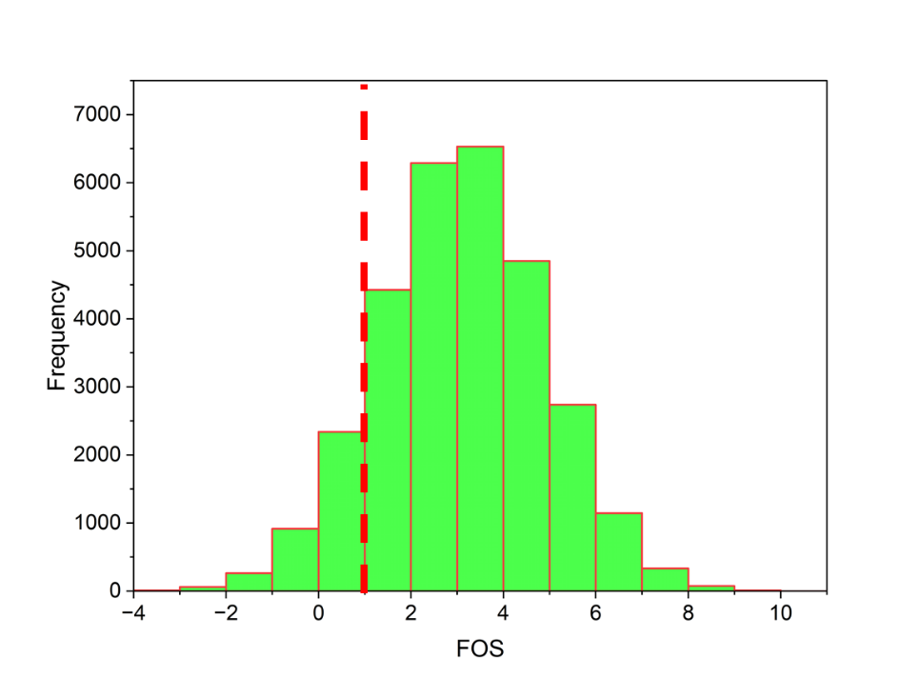

**Figure 19:** Monte Carlo Simulation

**Table 10:** Statistics of the variables

|  |  |  |  |  |  |  |  |
| --- | --- | --- | --- | --- | --- | --- | --- |
|  | **β** | **H** | **CD** | **NS (%)** | **c** | Ø° | **FOS** |
| Count | 52 | 52 | 52 | 52 | 52 | 52 | 52 |
| Mean | 37.5 | 9 | 41.54 | 2.07 | 125 | 28.93 | 3.09 |
| Std | 7.57 | 3.03 | 37.64 | 1.44 | 72.17 | 0.91 | 1.79 |
| Min | 30 | 6 | 0 | 0 | 30 | 27.57 | 0.62 |
| 25% | 30 | 6 | 0 | 0.5 | 76.38 | 28.17 | 1.765 |
| 50% | 37.5 | 9 | 45 | 1.5 | 107.93 | 28.73 | 2.64 |
| 75% | 45 | 12 | 90 | 3 | 163.82 | 29.56 | 3.9 |
| Max | 45 | 12 | 90 | 4 | 276.19 | 30.74 | 8.86 |
| **Probability of Failure** | | | | 12.25% | | | |

**7.3 Reliability Index of NS-stabilized Problematic Soil**

The Reliability Index (*δ*) for the NS-stabilized slope is shown in Figure 20. The stabilization method's ability to increase safety and lower the risk of failure under specific conditions is measured by the stabilization index, which serves as a proxy for the process' dependability or safety. This number is essential for comprehending how well NS stabilization works to improve the structural integrity of soils that are prone to landslides. It also sheds light on possible increases in soil reliability as a result of the stabilization process. As seen in Figure 20 the *δ* of FOS for all the dosages of NS is greater than 2 which shows that the calculated results are highly reliable.

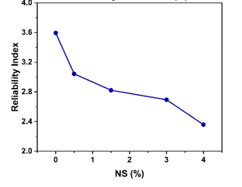

**Figure 20:** Reliability Index(*δ)*

**7.4 Probability of Failure of NS-stabilized Problematic Soil**

The *P*f for the NS-stabilized problematic soil is shown in Figure 21. The illustration most likely shows a graphical depiction of the probability that, in specific circumstances, the stabilized soil may fail. Because it shows the proportion of instances in which the soil's strength falls short of the necessary thresholds, the *P*f is an essential indicator for evaluating the efficacy of the soil stabilization procedure. The figure illustrates how *P*f drops as NS increases; that is, while *P*f in normal soil is nearly 60%, *P*f in 4% NS stabilized problematic soil is almost nil. The graph aids in understanding the risk involved in applying NS for soil stabilization by providing a visual representation of *P*f*.*

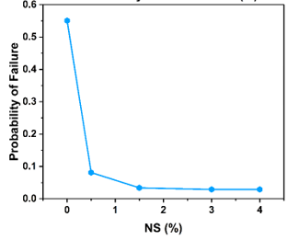

**Figure 21:** Probability of failure

**7.5 Covariance Analysis of Probability of Failure**

The variation of the various Coefficients of Variation (COVs) is shown in Figure 22 for *P*f. The ratio of the standard deviation to the mean, or COV, is a measure of relative variability. This graph aids in understanding how variations in soil property variability affect the stabilizing process' dependability. Across the range of NS dosages, the COVs with the lowest percentage (10%) demonstrated stronger reliability than those with larger COVs. It highlights the connection between soil property variability and stabilization effectiveness and offers insightful information on the NS stabilization method's resilience under various levels of soil property variability. Figure 22 offers important insights into the dependability and risk connected with the NS stabilization process under various soil conditions by showing how *P*f varies with varying amounts of variability.

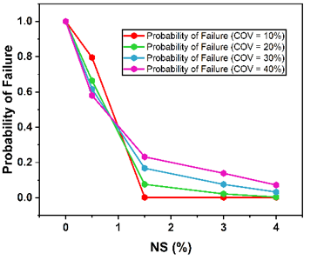

**Figure 22:** Probability of failure for different COVs

**8 Summary and Conclusions**

This research explored the seismic performance of finite slopes stabilized with NS using a pseudo-static approach to simulate earthquake forces. Through extensive numerical simulations and finite element modeling, it was demonstrated that NS plays a critical role in enhancing slope stability under seismic conditions. Specifically, the study revealed that NS-stabilized slopes showed a marked improvement in the safety factor, increasing by up to 6.7 times compared to non-stabilized slopes when subjected to earthquake forces. Additionally, horizontal displacement (*H*d) of the slopes was significantly reduced by 1.8% for 30° slopes and by 23% for 45° slopes, further highlighting the efficiency of NS stabilization.

The reliability analysis provided a deeper understanding of the robustness of NS-stabilized slopes, with the probability of failure dropping to 12.97%. This indicates that the use of NS not only enhances the structural integrity of slopes during seismic events but also mitigates the risk of catastrophic failure. The findings present strong evidence that Nano-silica, as a stabilizing agent, offers a practical, cost-effective solution for improving the seismic resilience of slopes, particularly in earthquake-prone regions. This study adds to the body of knowledge in geotechnical earthquake engineering by providing a detailed analysis of a novel stabilization technique. The successful application of a pseudo-static approach in evaluating slope performance under seismic forces also supports the use of this methodology for future studies. However, further research is required to explore the long-term effects of Nano-silica stabilization and its performance under dynamic (real-time) seismic forces, as well as its applicability to different soil types. In conclusion, this work demonstrates that Nano-silica is a promising material for slope stabilization, capable of significantly improving seismic safety and reliability.

**Acknowledgments**

NA.

**Author Contributions**

Ishwor Thapa: Conceptualization, Data collection, software, processing, results compilation, and writing the first draft

Sufyan Ghani: Conceptualization, finalizing and reviewing the final draft

.

**Declarations**

***Ethical Approval*** Not applicable

***Funding*** No funding was obtained for this study

***Competing interests,*** The authors declare no competing interests.

***Conflict of Interest*** On behalf of all authors, the corresponding author states that there is no conflict of interest.

***Data availability*** The data and supplementary material are available on request

**References**

Aroni Hesari, S., Javankhoshdel, S., Payan, M. and Jamshidi Chenari, R. 2022. “Pseudo-Static Internal Stability Analysis of Geosynthetic-Reinforced Earth Slopes Using Horizontal Slices Method”, *Geomechanics and Geoengineering*, vol. **17**, no. 5, pp. 1417–42, DOI: 10.1080/17486025.2021.1940316

Banne, S. P., Dhawale, A. W., Patil, R. B., Girase, M., Kulkarni, C., Dake, M. and Khan, S. 2024. “Slope Stability Analysis of Xanthan Gum Biopolymer Treated Laterite Soil Using Plaxis Limit Equilibrium Method (PLAXIS LE)”, *KSCE Journal of Civil Engineering*, vol. **28**, no. 4, pp. 1205–16, DOI: 10.1007/s12205-024-0553-2

Beygi, M., Vali, R. and Keshavarz, A. 2022. “Pseudo-Static Bearing Capacity of Strip Footing with Vertical Skirts Resting on Cohesionless Slopes by Finite Element Limit Analysis”, *Geomechanics and Geoengineering*, vol. **17**, no. 2, pp. 485–98, DOI: 10.1080/17486025.2020.1794058

Çadır, C. C., Vekli, M. and Şahinkaya, F. 2021a. “Numerical Analysis of a Finite Slope Improved with Stone Columns under the Effect of Earthquake Force”, *Natural Hazards*, vol. **106**, no. 1, pp. 173–211, DOI: 10.1007/s11069-020-04456-0

Çadır, C. C., Vekli, M. and Şahinkaya, F. 2021b. “Numerical Analysis of a Finite Slope Improved with Stone Columns under the Effect of Earthquake Force”, *Natural Hazards*, vol. **106**, no. 1, pp. 173–211, DOI: 10.1007/s11069-020-04456-0

Chen, M., Zhou, J. and Yang, X. 2024. “A Novel Approach for Slope Stability Evaluation Considering Landslide Dynamics and Its Application to Reservoir Landslide”, *Natural Hazards*, vol. **120**, no. 4, pp. 3589–3621, DOI: 10.1007/s11069-023-06343-w

Chimdesa, F. F., Chimdesa, F. F., Jilo, N. Z., Hulagabali, A., Babalola, O. E., Tiyasha, T., Ramaswamy, K., Kumar, A. and Bhagat, S. K. 2023. “Numerical Analysis of Pile Group, Piled Raft, and Footing Using Finite Element Software PLAXIS 2D and GEO5”, *Scientific Reports*, vol. **13**, no. 1, p. 15875, DOI: 10.1038/s41598-023-42783-x

Chiou, J.-S., Lee, Y.-W. and Chen, P.-C. 2024. “Improved Pseudostatic Analysis of Pile Response to Seismic Ground Movement: Multiple Characteristic Ground Displacement Profiles”, *Soil Dynamics and Earthquake Engineering*, vol. **181**, p. 108659, 2024. DOI: 10.1016/j.soildyn. 108659

Chwała, M., Phoon, K.-K., Uzielli, M., Zhang, J., Zhang, L. and Ching, J. 2023. “Time Capsule for Geotechnical Risk and Reliability”, *Georisk: Assessment and Management of Risk for Engineered Systems and Geohazards*, vol. **17**, no. 3, pp. 439–66, DOI: 10.1080/17499518.2022.2136717

Dar, L. A. and Shah, M. Y. 2021. “Deep-Seated Slope Stability Analysis and Development of Simplistic FOS Evaluation Models for Stone Column-Supported Embankments”, *Transportation Infrastructure Geotechnology*, vol. **8**, no. 2, pp. 203–27, DOI: 10.1007/s40515-020-00134-7

Farooq, M. U., Mujtaba, H., Farooq, K., Sivakugan, N. and Das, B. M. 2020. “Evaluation of Stability and Erosion Characteristics of Soil Embankment Slope Reinforced with Different Natural Additives”, *Iranian Journal of Science and Technology, Transactions of Civil Engineering*, vol. **44**, no. S1, pp. 515–24, DOI: 10.1007/s40996-019-00340-5

Ghani, S. and Kumari, S. 2024. “A Novel Tool for Probabilistic Modeling of Liquefaction Behavior in Alluvial Soil”, *Georisk: Assessment and Management of Risk for Engineered Systems and Geohazards*, vol. **0**, no. 0, pp. 1–24, https://doi.org/10.1080/17499518.2024.2395560

Ghani, S., Sapkota, S. C., Singh, R. K., Bardhan, A. and Asteris, P. G. 2024. “Modelling and Validation of Liquefaction Potential Index of Fine-Grained Soils Using Ensemble Learning Paradigms”, *Soil Dynamics and Earthquake Engineering*, vol. **177**, p. 108399, https://doi.org/10.1016/j.soildyn.2023.108399

Hazari, S., Ghosh, S. and Sharma, R. P. 2022. “Modified Pseudo-Dynamic Analysis of Slope Considering Logarithmic Spiral Failure Surface with Numerical Solution”, *Australian Journal of Civil Engineering*, vol. **20**, no. 2, pp. 399–423, DOI: 10.1080/14488353.2021.1995131

Ijaz, N., Ye, W., Rehman, Z. ur, Dai, F. and Ijaz, Z. 2021. “Numerical Study on Stability of Lignosulphonate-Based Stabilized Surficial Layer of Unsaturated Expansive Soil Slope Considering Hydro-Mechanical Effect”, *Transportation Geotechnics*, vol. **32**, p. 100697, January 2022. DOI: 10.1016/j.trgeo. 100697

Jain, H. and Kumar, J. 2023. “Displacements and Stresses around a Circular Tunnel in an Elastic Medium with Pseudo-Static Horizontal Earthquake Body Forces”, *Computers and Geotechnics*, vol. **162**, p. 105663, DOI: 10.1016/j.compgeo.2023.105663

Jaiswal, S. and Chauhan, V. B. 2022. “Influence of Secondary Reinforcement Layers to Enhance the Stability of Steep Soil Slope under Earthquake Loading”, *Arabian Journal of Geosciences*, vol. **15**, no. 11, p. 1095, DOI: 10.1007/s12517-022-10366-1

Jiang, S.-H., Liu, X., Wang, Z. Z., Li, D.-Q. and Huang, J. 2023. “Efficient Sampling of the Irregular Probability Distributions of Geotechnical Parameters for Reliability Analysis”, *Structural Safety*, vol. **101**, p. 102309, DOI: 10.1016/j.strusafe.2022.102309

Kassa, M. and Meten, M. 2023. “Slope Stability Analysis Using Kinematic, Limit Equilibrium, and Finite Element Models at Dessie Town, Northern Ethiopia”, *Arabian Journal of Geosciences*, vol. **16**, no. 12, p. 675, DOI: 10.1007/s12517-023-11783-6

Khorsandiardebili, N. and Ghazavi, M. 2022. “Internal Stability Analysis of Geocell-Reinforced Slopes Subjected to Seismic Loading Based on Pseudo-Static Approach”, *Geotextiles and Geomembranes*, vol. **50**, no. 3, pp. 393–407, DOI: 10.1016/j.geotexmem.2021.12.001

Kumari, S. and Ghani, S. 2024. “Prediction of Liquefaction Behaviour of Fine-Grained Soil Using Nature-Inspired Optimized Algorithms Coupled with Neural Network”, *Indian Geotechnical Journal*, from https://doi.org/10.1007/s40098-024-01016-2, DOI: 10.1007/s40098-024-01016-2

Kumar, N. and Kumari, S. 2024. “Slope Stability Analysis of Vetiver Grass Stabilized Soil Using Genetic Programming and Multivariate Adaptive Regression Splines”, *Transportation Infrastructure Geotechnology*, DOI: 10.1007/s40515-024-00423-5

Kumar, S., Choudhary, S. S. and Burman, A. 2023a. “Recent Advances in 3D Slope Stability Analysis: A Detailed Review”, *Modeling Earth Systems and Environment*, vol. **9**, no. 2, pp. 1445–62, DOI: 10.1007/s40808-022-01597-y

Kumar, S., Choudhary, S. S. and Burman, A. 2023b. “The Effect of Slope Height and Angle on the Safety Factor and Modes of Failure of 3D Slopes Analysis Using Limit Equilibrium Method”, *Beni-Suef University Journal of Basic and Applied Sciences*, vol. **12**, no. 1, p. 84, DOI: 10.1186/s43088-023-00423-3

Li, L., Zhao, D., Ni, B., Qiang, Y., Liu, G. and Zhou, L. 2022. “Study on the Stability Analysis of Rainfall Slope Based on G-A Model Considering Moisture Content”, *Scientific Reports*, vol. **12**, no. 1, p. 10480, DOI: 10.1038/s41598-022-14628-6

Liu, Y., Wu, R. and Yang, A. 2023. “Research on Medical Problems Based on Mathematical Models”, *Mathematics*, vol. **11**, no. 13, p. 2842, DOI: 10.3390/math11132842

Macedo, J. and Candia, G. 2020. “Performance-Based Assessment of the Seismic Pseudo-Static Coefficient Used in Slope Stability Analysis”, *Soil Dynamics and Earthquake Engineering*, vol. **133**, p. 106109, DOI: 10.1016/j.soildyn.2020.106109

Mircevska, V., Nastev, M. and Nanevska, A. 2022. “Seismic Slope Displacement of Tailings Dam: A Comparative Study between Modified Newmark and Mohr-Coulomb Models”, *Journal of Earthquake Engineering*, vol. **26**, no. 15, pp. 7878–7900, DOI: 10.1080/13632469.2021.1965053

Moghal, A. A. B., Chittoori, B. C. S. and Basha, B. M. 2018. “Effect of Fibre Reinforcement on CBR Behaviour of Lime-Blended Expansive Soils: Reliability Approach”, *Road Materials and Pavement Design*, vol. **19**, no. 3, pp. 690–709, DOI: 10.1080/14680629.2016.1272479

Moghal, A. A. B., Chittoori, B. C. S., Basha, B. M. and Al-Shamrani, M. A. 2017. “Target Reliability Approach to Study the Effect of Fiber Reinforcement on UCS Behavior of Lime Treated Semiarid Soil”, *Journal of Materials in Civil Engineering*, vol. **29**, no. 6, DOI: 10.1061/(ASCE)MT.1943-5533.0001835

NG, C. W. W., GUO, H., NI, J., ZHANG, Q. and CHEN, Z. 2022. “Effects of Soil–Plant-Biochar Interactions on Water Retention and Slope Stability under Various Rainfall Patterns”, *Landslides*, vol. **19**, no. 6, pp. 1379–90, DOI: 10.1007/s10346-022-01874-y

Patra, S. and Shahu, J. T. 2020. “Pseudo-Static Analysis of Reinforced Soil Wall Based on Pasternak Model”, *Indian Geotechnical Journal*, vol. **50**, no. 2, pp. 252–60, DOI: 10.1007/s40098-019-00400-7

Rao, B., Burman, A. and Roy, L. B. 2024. “An Efficient Box Search Method for Limit Equilibrium Method-Based 3D Slope Stability Analysis”, *Transportation Infrastructure Geotechnology*, vol. **11**, no. 1, pp. 327–58, DOI: 10.1007/s40515-023-00285-3

Rehman, Z. ur, Ijaz, N., Ye, W. and Ijaz, Z. 2023. “Design Optimization and Statistical Modeling of Recycled Waste-Based Additive for a Variety of Construction Scenarios on Heaving Ground”, *Environmental Science and Pollution Research*, vol. **30**, no. 14, pp. 39783–802, DOI: 10.1007/s11356-022-24853-1

Sadighi, H., Badiei, E. and Eslami Haghighat, A. 2022. “Rational Selection of Pseudostatic Seismic Coefficient of Slopes”, *Iranian Journal of Science and Technology, Transactions of Civil Engineering*, vol. **46**, no. 6, pp. 4529–41, DOI: 10.1007/s40996-022-00870-5

Sharma, S. and Prashant, A. 2023. “Seismic Coefficients for Pseudo-Static Analysis of Wrap-Faced GRS Walls with Nonlinear Soil Fills”, *Soil Dynamics and Earthquake Engineering*, vol. **171**, p. 107960, DOI: 10.1016/j.soildyn.2023.107960

Singh, S. K., Negi, M. S. and Singh, J. 2021. “Strengthening of Slope by Soil Nailing Using Finite Difference and Limit Equilibrium Methods”, *International Journal of Geosynthetics and Ground Engineering*, vol. **7**, no. 3, p. 64, DOI: 10.1007/s40891-021-00308-4

Spiekermann, R. I., McColl, S., Fuller, I., Dymond, J., Burkitt, L. and Smith, H. G. 2021. “Quantifying the Influence of Individual Trees on Slope Stability at Landscape Scale”, *Journal of Environmental Management*, vol. **286**, p. 112194, DOI: 10.1016/j.jenvman.2021.112194

Sudhakaran, S. P., Sharma, A. K. and Kolathayar, S. 2018. “Soil Stabilization Using Bottom Ash and Areca Fiber: Experimental Investigations and Reliability Analysis”, *Journal of Materials in Civil Engineering*, vol. **30**, no. 8, DOI: 10.1061/(ASCE)MT.1943-5533.0002326

Sumalatha, J. 2022. “Stability Analysis of Slopes at a Landslide Prone Area: A Case Study on the Landslide at Madikere, India”, pp. 105–14,

Syed, M. and GuhaRay, A. 2020. “Effect of Fiber Reinforcement on Mechanical Behavior of Alkali-Activated Binder-Treated Expansive Soil: Reliability-Based Approach”, *International Journal of Geomechanics*, vol. **20**, no. 12, DOI: 10.1061/(ASCE)GM.1943-5622.0001871

Tucho, A., Indraratna, B. and Ngo, T. 2022. “Stress-Deformation Analysis of Rail Substructure under Moving Wheel Load”, *Transportation Geotechnics*, vol. **36**, p. 100805, DOI: 10.1016/j.trgeo.2022.100805

Wang, L., Gao, Y., Zhou, E., Feng, J., Huang, A. and Xu, M. 2024. “Pseudo-Static Analysis of 3D Unsaturated Bench Slopes Stabilized by Multiple Rows of Piles”, *Transportation Geotechnics*, vol. **46**, p. 101255, DOI: 10.1016/j.trgeo.2024.101255

Wang, Y. and Orense, R. P. 2022. “Consideration of Batter Angle in Pseudo-Static Analyses of Pile Foundations”, *Computers and Geotechnics*, vol. **147**, p. 104767, DOI: 10.1016/j.compgeo.2022.104767

Wang, Z. Z. and Jiang, S.-H. 2023. “Characterizing Geotechnical Site Investigation Data: A Comparative Study Using a Novel Distribution Model”, *Acta Geotechnica*, vol. **18**, no. 4, pp. 1821–39, DOI: 10.1007/s11440-022-01720-4

Xue, T., Ye, S. and Cao, C. 2023. “Permanent Displacement Analysis of Multistage Loess Slopes with Multiple Slip Surfaces Based on Energy Methods”, *International Journal of Geomechanics*, vol. **23**, no. 11, DOI: 10.1061/IJGNAI.GMENG-8954

Yang, C.-M., Dong, J.-J., Lee, C.-T., Cheng, H.-Y., Hsu, C.-H., Nguyen, T.-P., Lai, C.-J. and Wu, W.-J. 2024. “Revisit the Classical Newmark Displacement Analysis for Earthquake-Induced Wedge Sliding of a Rock Slope”, *Engineering Geology*, vol. **328**, p. 107374, January DOI: 10.1016/j.enggeo.2023.107374

Yazdandoust, M., Jamnani, A. R. and Sabermahani, M. 2024. “The Use of the Horizontal Slice Method to Determine the Pseudostatic Coefficient in Two-Tiered Geogrid and Metal Strip–Reinforced Soil Walls”, *International Journal of Geomechanics*, vol. **24**, no. 4, DOI: 10.1061/IJGNAI.GMENG-9753

Yazdi, M. 2024. “Integration of Computational Mathematics in Industrial Decision-Making”, pp. 105–20,

Ye, S. H. and Zhang, R. H. 2023. “Stability Analysis of Multistage Loess Slope Under Earthquake Action Based on the Pseudo-Static Method”, *Soil Mechanics and Foundation Engineering*, vol. **60**, no. 4, pp. 304–13, DOI: 10.1007/s11204-023-09896-x

Yeznabad, A. F., Molnar, S., Naggar, M. H. El and Ghofrani, H. 2022. “Estimation of Probabilistic Seismic Sliding Displacement and Pseudo-Static Coefficients (K15) for Seismic Stability Assessment of Slopes in the Southern Lower Mainland, British Columbia”, *Soil Dynamics and Earthquake Engineering*, vol. **161**, p. 107364, DOI: 10.1016/j.soildyn.2022.107364

Zhang, Y., Li, F. and Jia, D. 2022. “Lattice Impeller Design and Multi-Scale Stress-Deformation Analysis Based on Conventional Cubic Lattice”, *Mechanics of Advanced Materials and Structures*, vol. **29**, no. 15, pp. 2235–49, DOI: 10.1080/15376494.2020.1855681

Zhang, Z.-L. and Yang, X.-L. 2021. “Seismic Stability Analysis of Slopes with Cracks in Unsaturated Soils Using Pseudo-Dynamic Approach”, *Transportation Geotechnics*, vol. **29**, p. 100583, DOI: 10.1016/j.trgeo.2021.100583

Zhao, H., Li, S., Zang, X., Liu, X., Zhang, L. and Ren, J. 2024. “Uncertainty Quantification of Inverse Analysis for Geomaterials Using Probabilistic Programming”, *Journal of Rock Mechanics and Geotechnical Engineering*, vol. **16**, no. 3, pp. 895–908, DOI: 10.1016/j.jrmge.2023.07.014

Zhao, L., Jiao, K., Li, D. and Zuo, S. 2020. “System Reliability Analysis of Seismic Pseudo-Static Stability of Rock Wedge Based on Nonlinear Barton—Bandis Criterion”, *Journal of Central South University*, vol. **27**, no. 11, pp. 3450–63, DOI: 10.1007/s11771-020-4558-9

Zhou, J. and Qin, C. 2020. “Finite-Element Upper-Bound Analysis of Seismic Slope Stability Considering Pseudo-Dynamic Approach”, *Computers and Geotechnics*, vol. **122**, p. 103530, DOI: 10.1016/j.compgeo.2020.103530